

**Management & Science University,  
University Drive, Off Persiaran Olahraga,  
Section 13, 40100 Shah Alam,  
Selangor Darul Ehsan.**

**POSTGRAD THESIS MONITORING and CONTROLLING SYSTEM**

**(PGTMCS)**

**USER MANUAL for Supervisor/Co-Supervisor & Reviewer**

Version 1.0

Document Reference: MSU/PGTMCS/UM/003

**DOCUMENT DETAILS**

|  |  |
| --- | --- |
| **Effective Date:** | 1st June 2015 |
| **Document Owner:** | Information Technology and Innovation Centre (ITIC) |

**REVISION HISTORY**

|  |  |  |  |
| --- | --- | --- | --- |
| **Date** | **Version** | **Description** | **Author** |
| 18th February 2015 | 0.1 | Document creation | Zuraimi, Amalina |
| 02nd March 2015 | 0.2 | Document review and update | Zuraimi |
| 19th May 2015 | 1.0 | Final | Zuraimi , Nizam |

**TABLE OF CONTENTS**

1 INTRODUCTION 7

1.1 Scope 7

1.2 System Requirement 7

1.2.1 URL 7

1.2.2 Internet Browser 7

1.2.3 User Access 8

1.3 Screen Design 8

2 HIGHLEVEL FLOW 10

2.1 Thesis Proposal Submission Process Flow 10

3 USER LOGIN and LOGOUT 11

3.1 Login 11

3.2 Logout 11

4 CHANGE PASSWORD 12

4.1 Change Password 12

5 THESIS PROFILE 13

5.1 Student Profile 14

5.2 Thesis 14

5.3 Supervisor/Co-Supervisor List 15

5.4 Subject Taken 16

5.5 Thesis History 16

6 STUDENT PROFILE 18

6.1 Student Profile 19

6.2 Thesis 19

6.3 Supervisor/Co-Supervisor List 19

6.4 Subject Taken 21

6.5 Thesis History 21

7 SUPERVISOR BIODATA 23

8 INVITATION ACCEPTANCE 24

8.1 Enter Remarks 25

8.2 Outline of Cased Study 25

8.3 Accept/Reject Invitation 27

9 REVIEWER FEEDBACK 28

9.1 Enter Feedback 29

9.2 Thesis Detail 29

9.3 Submit Feedback 30

10 MONTHLY PROGRESS REPORT 31

10.1 Progress Report History 31

10.1.1 View Detail 32

10.2 Review Progress Report 34

10.2.1 View Progress Report Detail 35

10.2.2 Review Progress Report 36

11 Message 40

11.1 Inbox 40

11.1.1 View Message 41

11.2 New Message 42

11.2.1 Select Recipient 43

11.2.2 Upload Attachment 44

11.3 Sent 45

11.3.1 Read Message 46

Email Template - Faculty to Student 48

Thesis Proposal - Request Change 48

Thesis Proposal - Disapproved 49

Email Template - Supervisor to Student 50

Monthly Progress Report - Request Change 50

Monthly Progress Report - Approved 51

**LIST OF FIGURES**

Figure 1: PGTMCS Screen Structure Design 9

Figure 2: Thesis Proposal Submission Process Flow 10

Figure 3: Login Page 11

Figure 4: Logout Page 12

Figure 5: Change Password Page 12

Figure 6: Student Programme Tab 13

Figure 7: Student Programme Tab 14

Figure 8: List of Supervisor / Co-Supervisor 15

Figure 9: Subject Taken 16

Figure 10: Thesis History 17

Figure 11: List of Student 18

Figure 12: Student Programme Tab 19

Figure 13: List of Supervisor / Co-Supervisor 20

Figure 14: Subject Taken 21

Figure 15: Thesis History 22

Figure 16: Supervisor Biodata 23

Figure 17: Attachment to Supervisor Biodata 23

Figure 18: Invitation Acceptance 24

Figure 19: Invitation Acceptance - Remark 25

Figure 20: Outline of Resarch/Case Study 26

Figure 21: Accept/Reject Invitation 27

Figure 22: Reviewer Feedback 28

Figure 23: Enter Feedback 29

Figure 24: Thesis Detail 30

Figure 25: Feedback Submission 30

Figure 26: Monthly Progress Report 31

Figure 27: List of Progress Report History 32

Figure 28: Thesis Detail 32

Figure 29: Progress Report History Detail 33

Figure 30: Review Progress Report 34

Figure 31: Progress Report Detail 35

Figure 32: Progress Report Detail 35

Figure 33: Review Progress Detail 36

Figure 34: Progress Report Detail 36

Figure 35: Issue facing by Student 37

Figure 36: Advice from Supervisor 37

Figure 37: Upload Attachment 38

Figure 38: Browse 38

Figure 39: Choose Attachment 39

Figure 40: Finish Upload 39

Figure 41: List of attachment 39

Figure 42: Finish uploading 39

Figure 43: Supervisor Decision 39

Figure 44: Message 40

Figure 45: Read Message 41

Figure 46: New Message 42

Figure 47: Select Recipient 43

Figure 48: Select Recipient- Next Section 43

Figure 49: Upload Attachment 44

Figure 50: Upload Attachment- Next Section 44

Figure 51: Sent 45

Figure 52: Read Message 46

# INTRODUCTION

Postgraduate Thesis Monitoring and Controlling System (PGTMCS) version 1.0.0 is a system for the Student, Supervisor, Faculty and Senate to monitor the status of thesis proposal from its initial stage toward to the end. It is not only use by the respective personnel to control and manage the quality of the thesis to meet the university standard but it also can be used to keep track all the communication between the student and university. If required the history can be retrieved to view the completed work or its progress.

The system contains the main modules which are Thesis Proposal Submission and Approval, Monthly Progress Report Review, Thesis Proposal Defense, Thesis Work Completion, Thesis Evaluation/Viva and Senate Endorsement.

The Thesis Proposal Submission and Approval module will be the first release made available for use by the student and staffs. The rest of the module will be released by stages.

## Scope

As the scope of this manual will cover the first release of the module, it will guide the student how to use the system and what would they need to do in the case of proposal get approved, changes needed or disapproved by the faculty or senate.

The student also will know the status of the proposal for each of the proposal stage either in draft mode, pending decision or it has been confirmed / approved by the Faculty or Senate.

The remaining guideline for other modules will be updated in the next user manual release.

## System Requirement

### URL

The system is available over the internet via the URL <http://postgrad.msu.edu.my> and accessible only by the registered and authorized postgraduate student and respective MSU’s staff.

### Internet Browser

It is recommended to run the system on the following internet browser

* Mozilla Firefox version 35 and above
* Microsoft Internet Explorer version 8 and above

### User Access

The postgraduate student who has been successfully registered in Campus Management System (CMS) will be automatically become postgraduate user or otherwise the student needs to check with the CMS admin on his/her status. By default Student Matrix Number will be the user id to access the PGTMCS system.

The MSU’s staff that has been identified as reviewer, supervisor or co-supervisor can access the PGTMCS system once the PGTMCS admin registered him/her into the system. By default Staff ID will be the user id to access the PGTMCS system.

## Screen Design

The PGTMCS system screen has been design into the 5 sections namely section A, B, C, D and E.

Section A to cater the PGTMCS **Header** in which it contains the name of the system, the user name and Logout button

Section B to cater the PGTMCS **Top Panel** in which it contains the list of functions for the system.

Section C to cater the PGTMCS **Left Panel** in which it contains the list of sub-functions resulting from the selection in Section B.

Section D to cater the PGTMCS **Working Area** in which it shows the page for user respond resulting from the selection in Section C.

Section E to cater the PGTMCS **Footer** in which it contains the university name and its copyright.

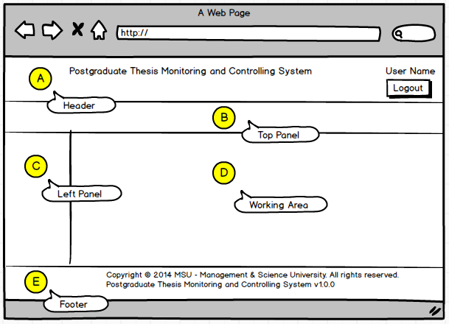

Figure 1: PGTMCS Screen Structure Design

# HIGHLEVEL FLOW

## Thesis Proposal Submission Process Flow

The figure below depicts the highlevel process flow for the thesis proposal submission which cover from the submission until its get approved by the Senate.

The dotted line as shown below is the focus covered in this manual.

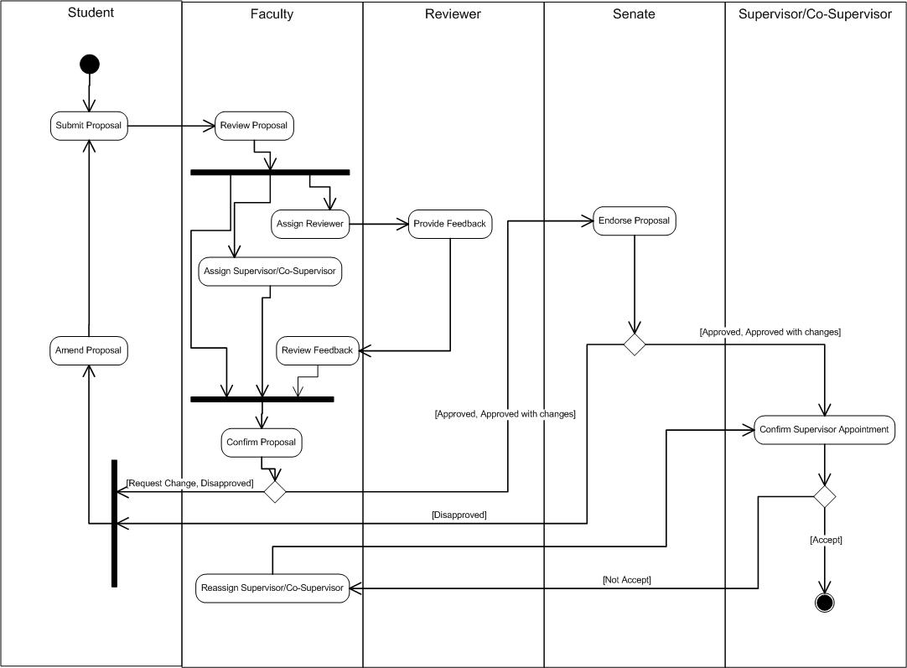

Figure 2: Thesis Proposal Submission Process Flow

# USER LOGIN and LOGOUT

## Login

This is the first page sight by the student to enter the PGTMC system.

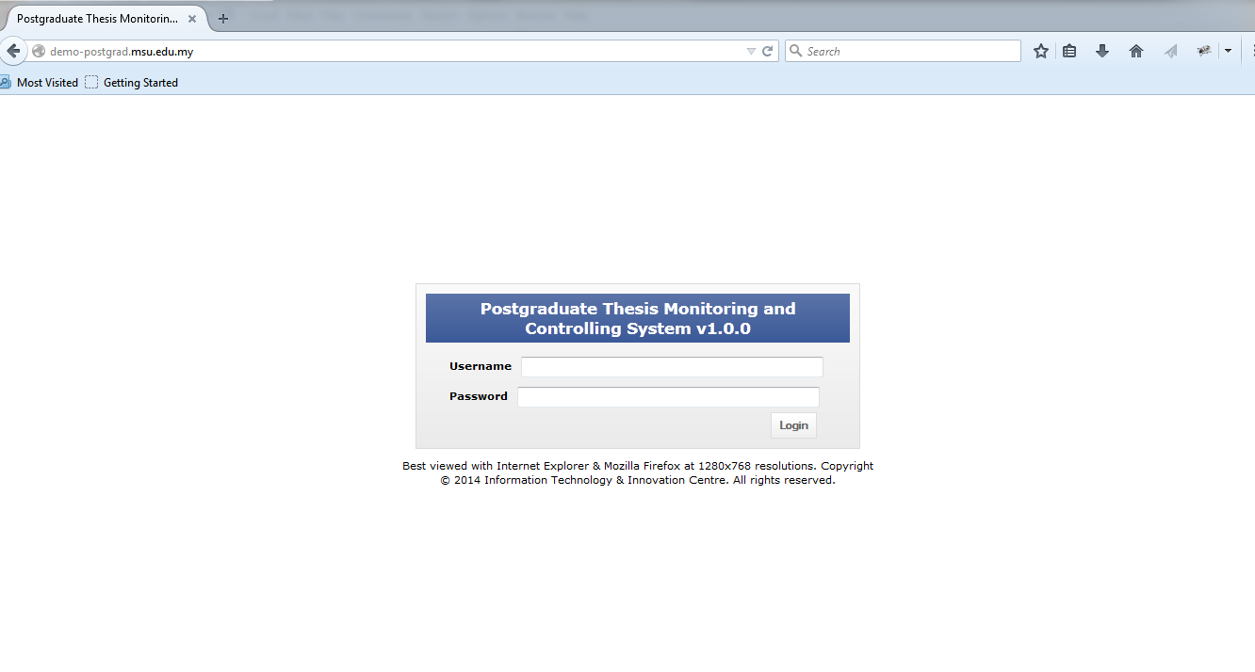

Student need to **login** Postgraduate Thesis System to create a New Proposal.

Figure 3: Login Page

**Steps:-**

1. Open any Internet Browser of your choice either Mozilla Firefox or Microsoft Internet Explorer
2. Enter the URL to access the system as follows <http://postgrad.msu.edu.my/>
3. Login page will be displayed in which the valid user credential needs to be provided i.e. **Username** and **Password**.

## Logout

Once the necessary or required activities has been done or completed, the student can quit from the system by clicking on the **Logout** button.

If the system is keep idle for about 1 minute, the system will logged out the user automatically.

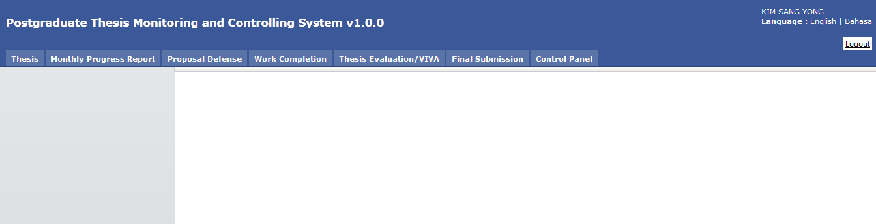

Button **Logout**.

Figure 4: Logout Page

**Steps:-**

1. Find the **Logout** button located on the right top corner of the system **Header** section.
2. Click on it and you will be logout from the system successfully.

# CHANGE PASSWORD

## Change Password

For the security reason, the user is strongly recommended to change the password at first successful login to the system.

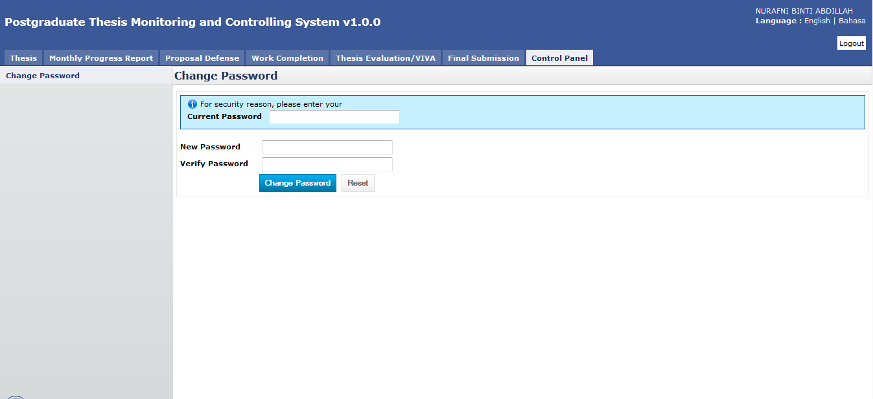

Figure 5: Change Password Page

**Steps:-**

1. Click on the **Control Panel** tab from the system **Top** panel section.
2. The **Change Password** menu will be displayed and click on it.
3. As to ensure the right user able to change the password, the system will ask **Current Password** used before able to change it to the new password.
4. Once the **Current Password** has been provided, the **New Password** and **Verify Password** can be provided afterward.
5. Click **Change Password** button to ensure the new password can be saved into the system successfully.
6. If the **Current Password** is incorrect, the system will prompt an error message and the user needs to redo the same steps above.
7. User can use **Reset** button if wanted to clear the entry on each fields.

# THESIS PROFILE

Thesis Profile listed all the supervisee under supervisor. Plus, the Supervisor can also view all the detail regarding supervisee. Search supervisee by Thesis ID/Title.

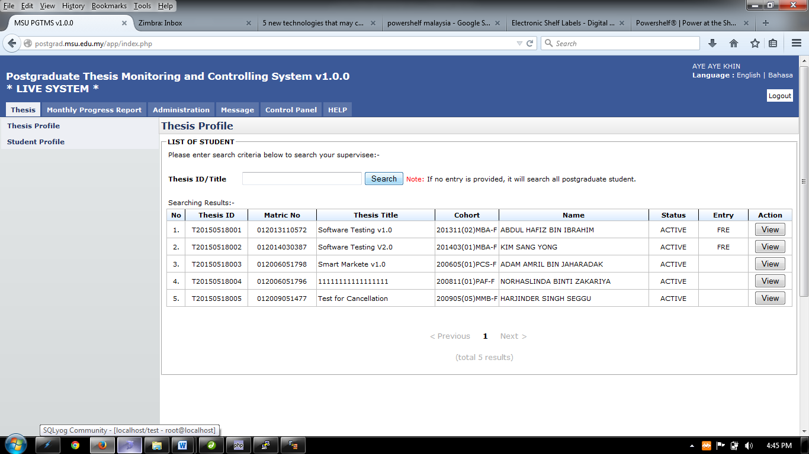

Figure 6: Student Programme Tab

**Pre-condition**

1. Supervisor/Co-Supervisor already accept invitation from Senate

**Post-condition**

1. View supervisee detail

**Steps:-**

1. Click on the **Thesis** tab on the system **Top** panel section.
2. The **Thesis Profile** menu will be displayed on the system **Left** panel and click on it.
3. Enter Thesis ID or Title, then click S**earch** button to view the searching result.
4. Then click **View** button to proceed. Refer 4.1: Student Profile

## Student Profile

Student Profile tab contains the basic student and thesis information including its thesis progress status.

Menu Tab for Student Profile, Thesis, Supervisor/Co-supervisor, Subject Taken, and Thesis History

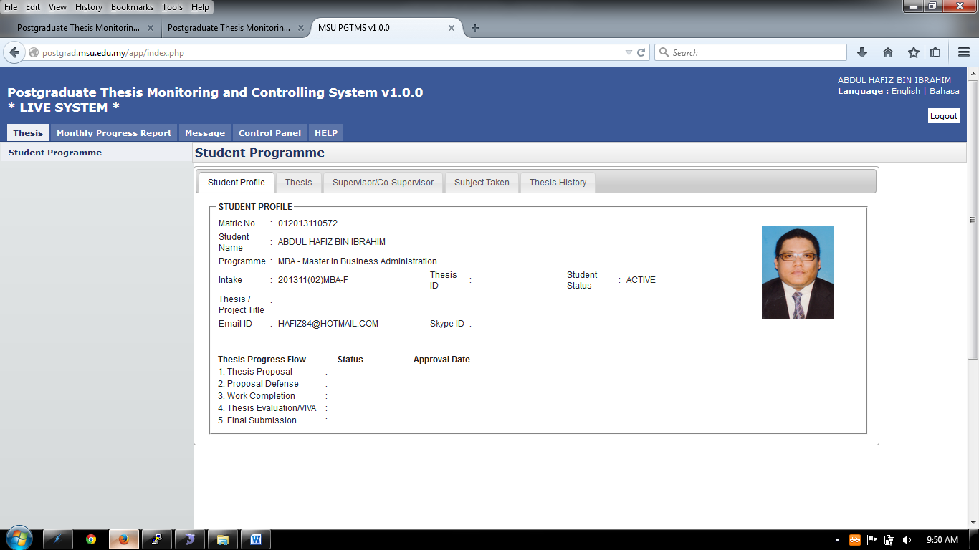

Figure 7: Student Programme Tab

**Steps:-**

1. Click on the **Thesis** tab on the system **Top** panel section.
2. The **Student Programme** menu will be displayed on the system **Left** panel and click on it.
3. The other 5 tabs will be displayed on the **Working Area** section in which each tab will contain the information as mentioned previously.

## Thesis

**Thesis** tab is the page where the student can submit, amend and view the proposal. Please refer next sections for details steps.

Each thesis proposal will be assigned with the Thesis ID which follows the naming convention below:

*The Date when the proposal is sent submitted*

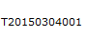

*Running number*

*It stands for Thesis*

## Supervisor/Co-Supervisor List

Supervisor or Co-Supervisor is the academic staff who has been assigned by Faculty to supervise the student in delivering the thesis and approved by the Senate.

There are conditions for the student to see the list of his/her supervisors. The conditions are:-

1. Supervisor/Co-Supervisor has been assigned by Faculty and approved by the Senate
2. Supervisor/Co-Supervisor has accepted the appointment to supervise the student.

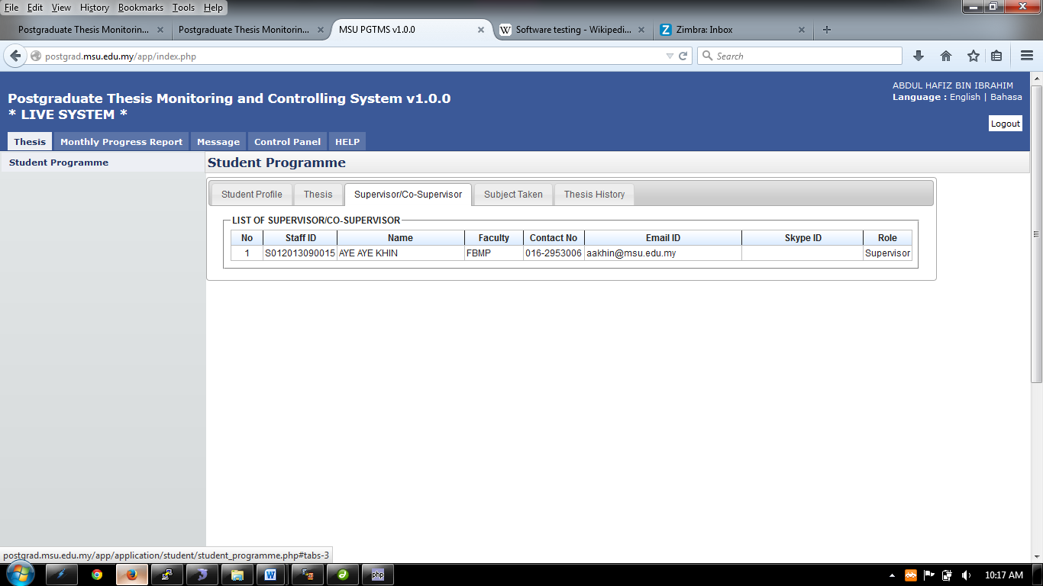

Figure 8: List of Supervisor / Co-Supervisor

**Steps:-**

1. Click on the **Thesis** tab on the **Top** panel
2. Click on the **Student Programme** menu on the **Left** panel
3. Click on the **Supervisor/Co-Supervisor** tab on the **Working Area**
4. System will display the list of the supervisor/co-supervisor which has been assigned and approved by Senate.

## Subject Taken

Subject Taken tab will list the entire subject registered by the students for all semester during his study.

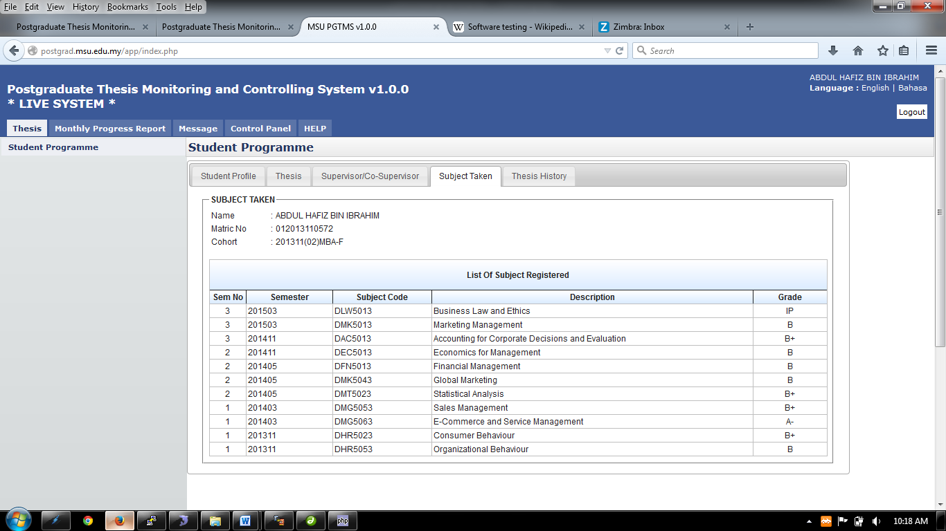

Figure 9: Subject Taken

**Steps:-**

1. Click on the **Thesis** tab on the **Top** panel
2. Click on the **Student Programme** menu on the **Left** panel
3. Click on the **Subject Taken** tab on the **Working Area**
4. System will display the list of the subject taken by the student from his/her first semester till current.

## Thesis History

Thesis History tab contains the proposal progress history starting from its submission by the student tills its approval by the Senate. It captures the alphabet, date when it was send and the running number at behind.

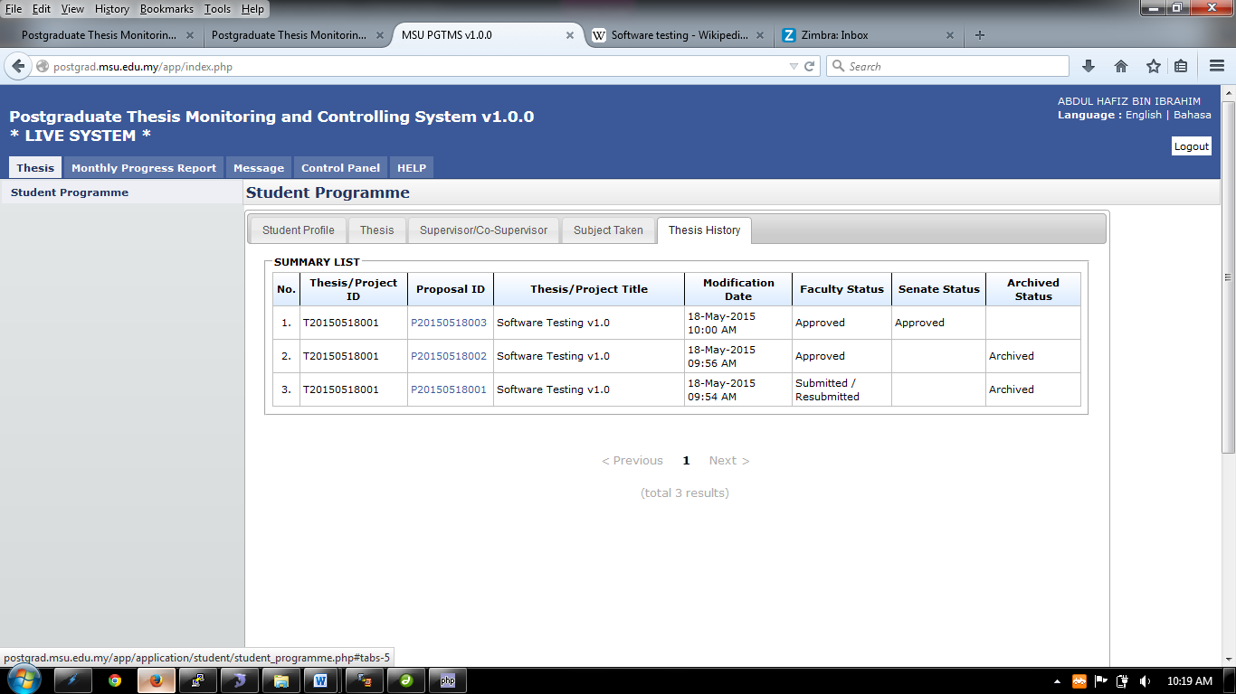

Figure 10: Thesis History

**Steps:-**

1. Click on the **Thesis** tab on the **Top** panel
2. Click on the **Student Programme** menu on the **Left** panel
3. Click on the **Thesis History** tab on the **Working Area**
4. System will display the list of the thesis history starting from its submission till its approval.

# STUDENT PROFILE

Student Profile listed all the supervisee under supervisor. Plus, the Supervisor can also view all the detail regarding supervisee. Search supervisee by Student Name.

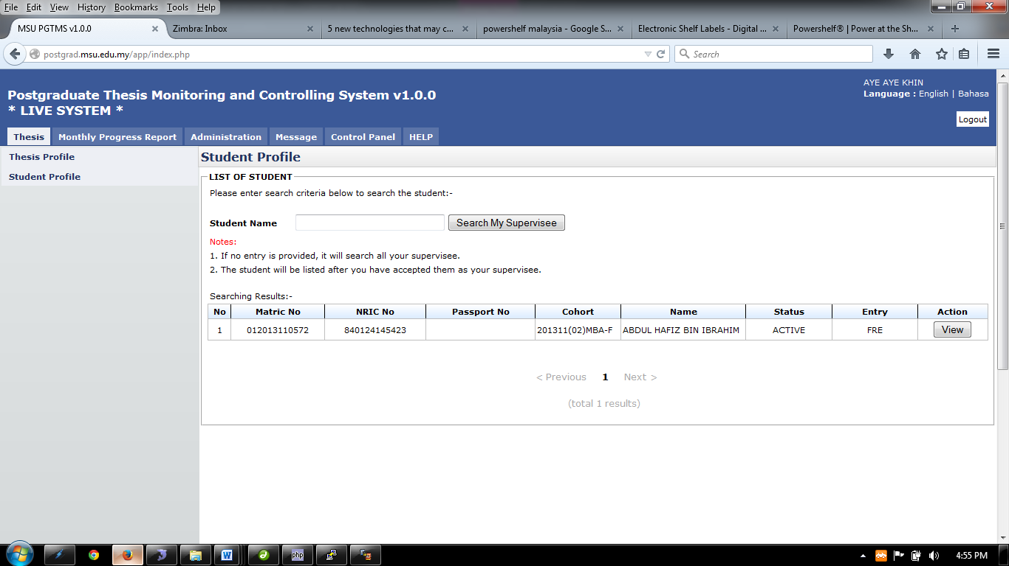

Figure 11: List of Student

**Steps:-**

1. Click on the **Thesis** tab on the system **Top** panel section.
2. The **Student Profile** menu will be displayed on the system **Left** panel and click on it.
3. Enter Thesis ID or Title, then click S**earch** button to view the searching result.
4. Then click **View** button to proceed. Refer 5.1: Student Profile

## Student Profile

Student Profile tab contains the basic student and thesis information including its thesis progress status.

Menu Tab for Student Profile, Thesis, Supervisor/Co-supervisor, Subject Taken, and Thesis History



Figure 12: Student Programme Tab

**Steps:-**

1. Click on the **Thesis** tab on the system **Top** panel section.
2. The **Student Programme** menu will be displayed on the system **Left** panel and click on it.
3. The other 5 tabs will be displayed on the **Working Area** section in which each tab will contain the information as mentioned previously.

## Thesis

**Thesis** tab is the page where the student can submit, amend and view the proposal. Please refer next sections for details steps.

## Supervisor/Co-Supervisor List

Supervisor or Co-Supervisor is the academic staff who has been assigned by Faculty to supervise the student in delivering the thesis and approved by the Senate.

There are conditions for the student to see the list of his/her supervisors. The conditions are:-

1. Supervisor/Co-Supervisor has been assigned by Faculty and approved by the Senate
2. Supervisor/Co-Supervisor has accepted the appointment to supervise the student.



Figure 13: List of Supervisor / Co-Supervisor

**Steps:-**

1. Click on the **Thesis** tab on the **Top** panel
2. Click on the **Student Programme** menu on the **Left** panel
3. Click on the **Supervisor/Co-Supervisor** tab on the **Working Area**
4. System will display the list of the supervisor/co-supervisor which has been assigned and approved by Senate.

## Subject Taken

Subject Taken tab will list the entire subject registered by the students for all semester during his study.



Figure 14: Subject Taken

**Steps:-**

1. Click on the **Thesis** tab on the **Top** panel
2. Click on the **Student Programme** menu on the **Left** panel
3. Click on the **Subject Taken** tab on the **Working Area**
4. System will display the list of the subject taken by the student from his/her first semester till current.

## Thesis History

Thesis History tab contains the proposal progress history starting from its submission by the student tills its approval by the Senate. It captures the alphabet, date when it was send and the running number at behind.



Figure 15: Thesis History

**Steps:-**

1. Click on the **Thesis** tab on the **Top** panel
2. Click on the **Student Programme** menu on the **Left** panel
3. Click on the **Thesis History** tab on the **Working Area**
4. System will display the list of the thesis history starting from its submission till its approval.

# SUPERVISOR BIODATA

This page is the place where each Supervisor / Co-Supervisor update their biodata related to education qualification, working experience, consultations, teaching experiences and etc. This information would help the Faculty to understand their background to guide and assist the student in their study and research.

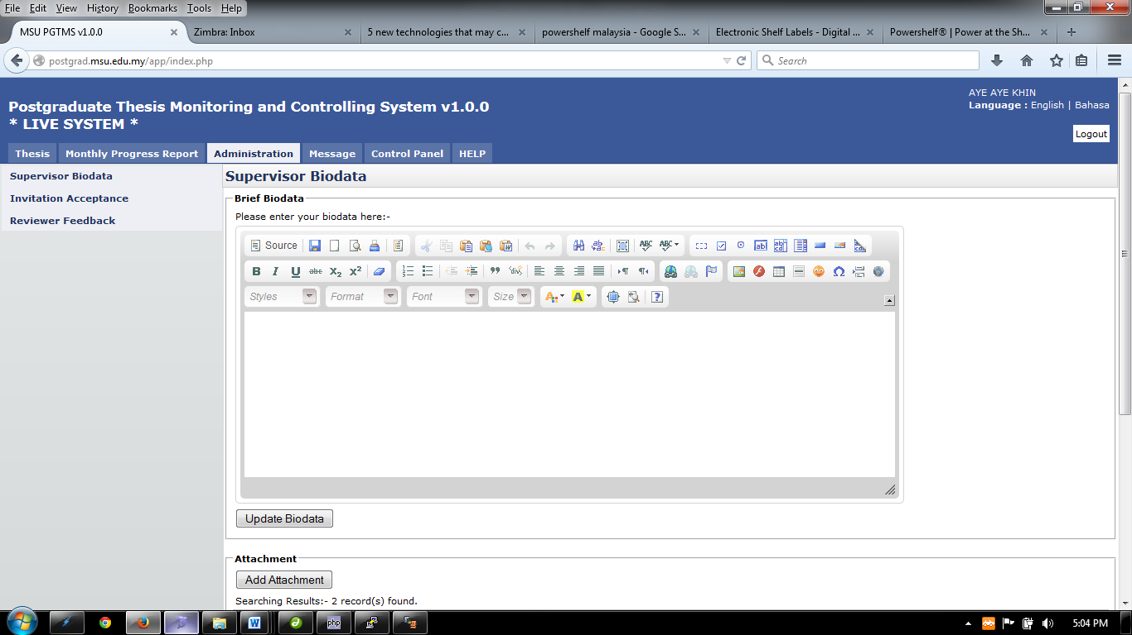

Figure 16: Supervisor Biodata

**Steps:-**

1. Click on the **Administration** tab on the system **Top** panel section.
2. The **Supervisor Biodata** menu will be displayed on the system **Left** panel and click on it.
3. Insert necessary detail and click **Update** button

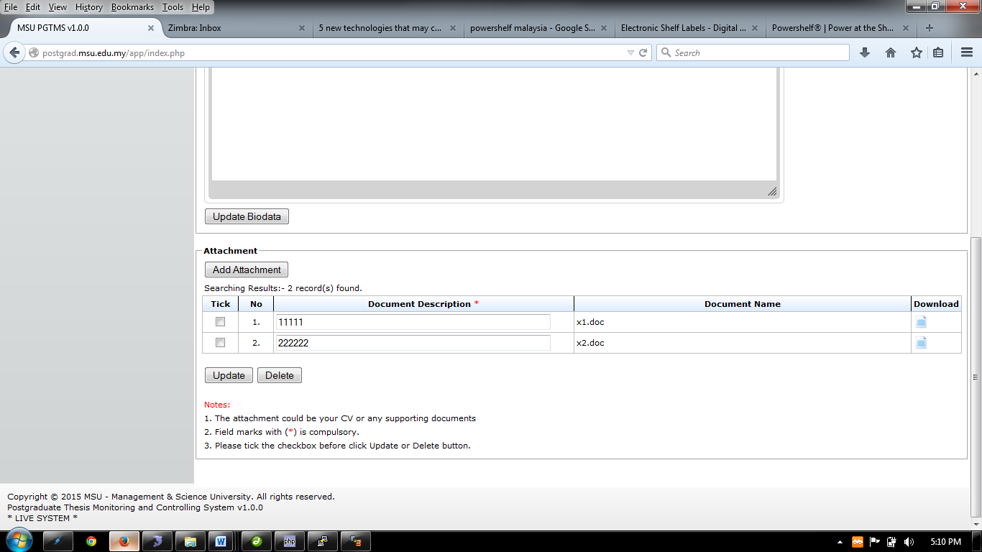

Figure 17: Attachment to Supervisor Biodata

**Steps:-**

1. **Add Attachment** button to add attachment regarding supervisor biodata
2. Tick any attachment to delete and click **Delete** button.
3. Click to download the file that has been upload.
4. To update the document description, edit the document description column, tick the checkbox and click **Update** button.

# INVITATION ACCEPTANCE

Invitation acceptance contain list of thesis that been assign by senate to the supervisor.

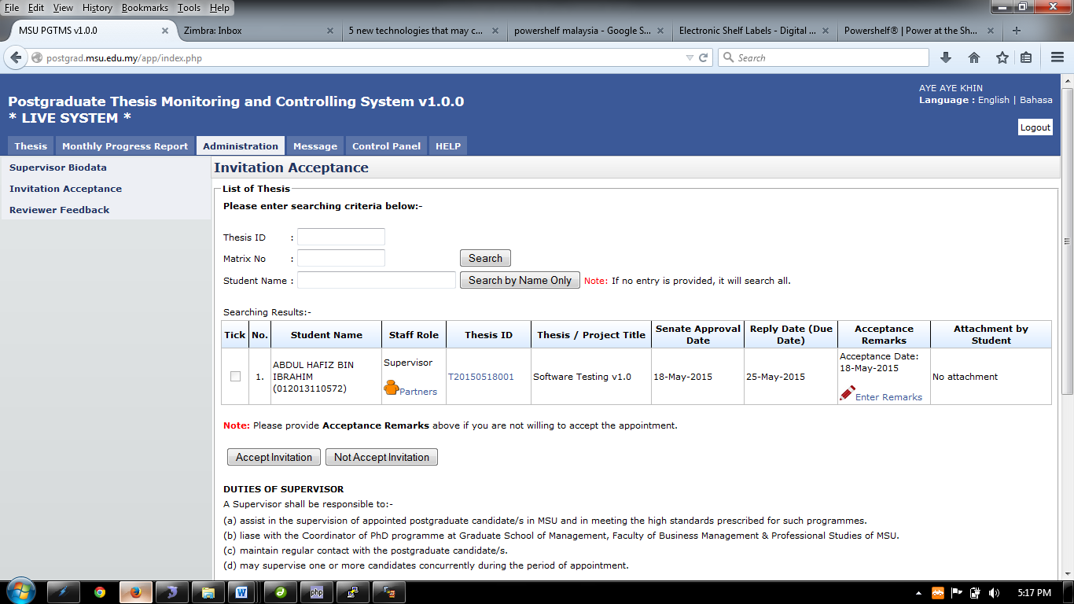Figure 18: Invitation Acceptance

**Pre-condition**

1. Senate approved thesis

**Post-condition**

1. Can review monthly progress report sent by student.

**Steps:-**

1. Click on the **Administration** tab on the system **Top** panel section.
2. The **Administration** menu will be displayed on the system **Left** panel and click on it.
3. Click the **Invitation Acceptance** and the searching page will be displayed which the user can search for a particular thesis to accept or reject the invitation assign by senate.
4. Enter the **Thesis’s ID** or **Matrix No**. into the field and click on **Search** button to search invitation
5. The record will be displayed under the search result.
6. **Or** Invitation can be search via **Student Name** by enter the student name and click **Search by Student Name Only.**
7. The record will be displayed under the search result
8. To give the remarks or read the feedback, click on the link  or 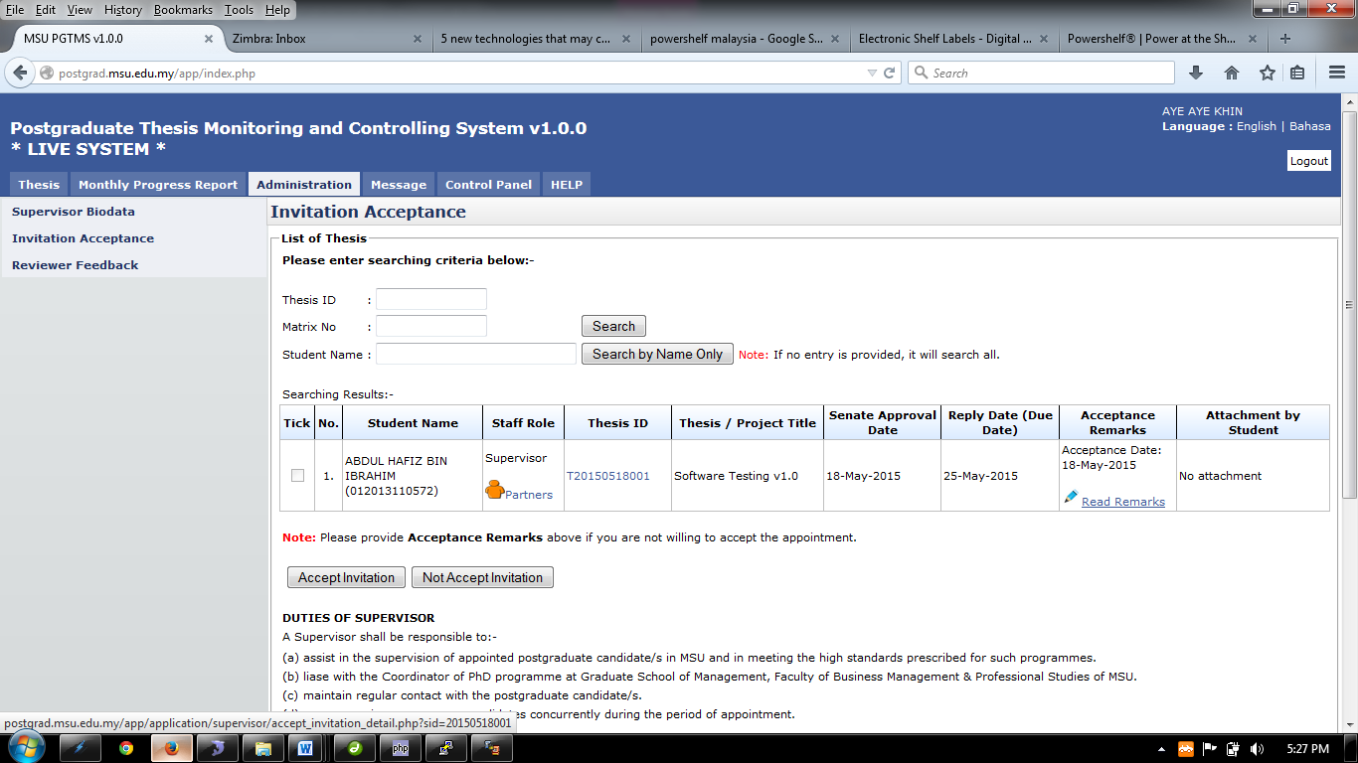.(Refer 7.1: Enter Remarks)
9. To View Thesis Detail, Click on Thesis ID. (Refer 7.2: Outline of Case Study)

## Enter Remarks

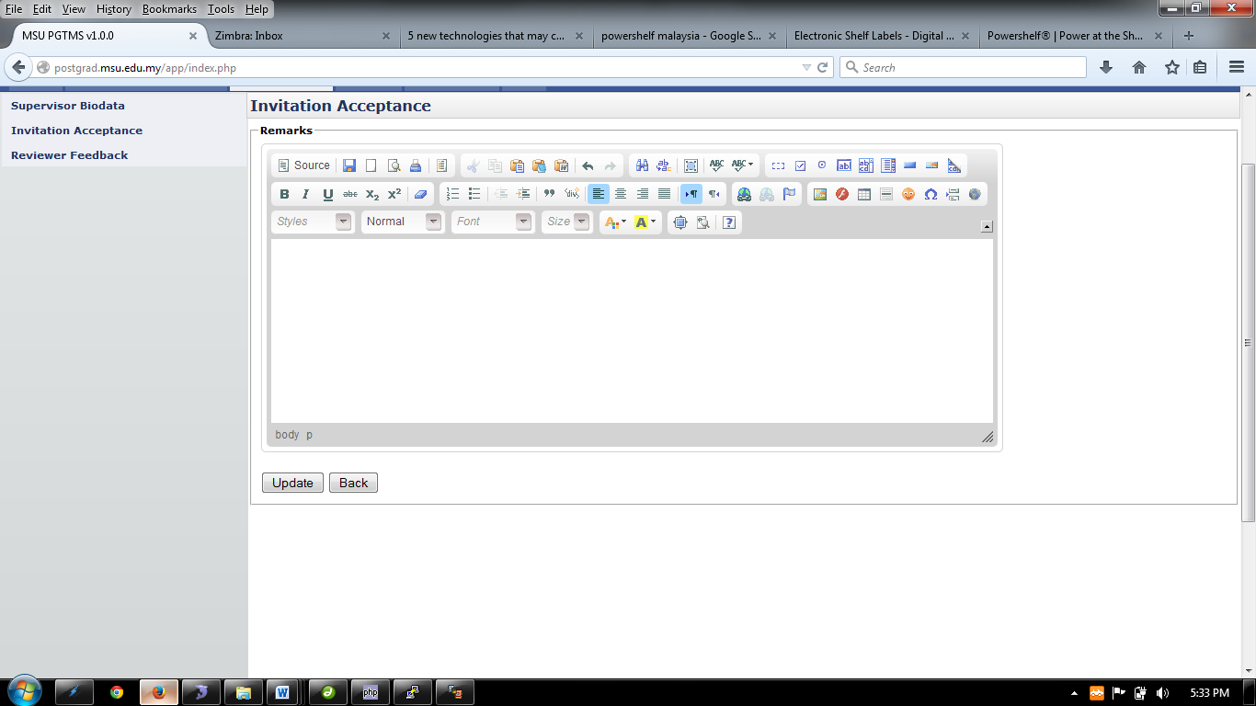

Figure 19: Invitation Acceptance - Remark

**Steps:-**

1. Enter necessary remark and click **Update** button.
2. To go back to the previous page, click **Back** button

## Outline of Cased Study

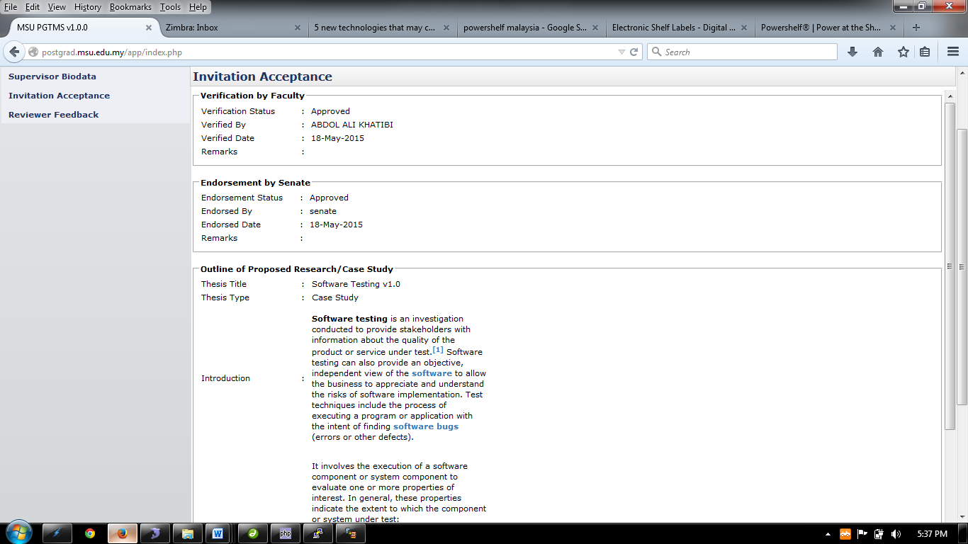

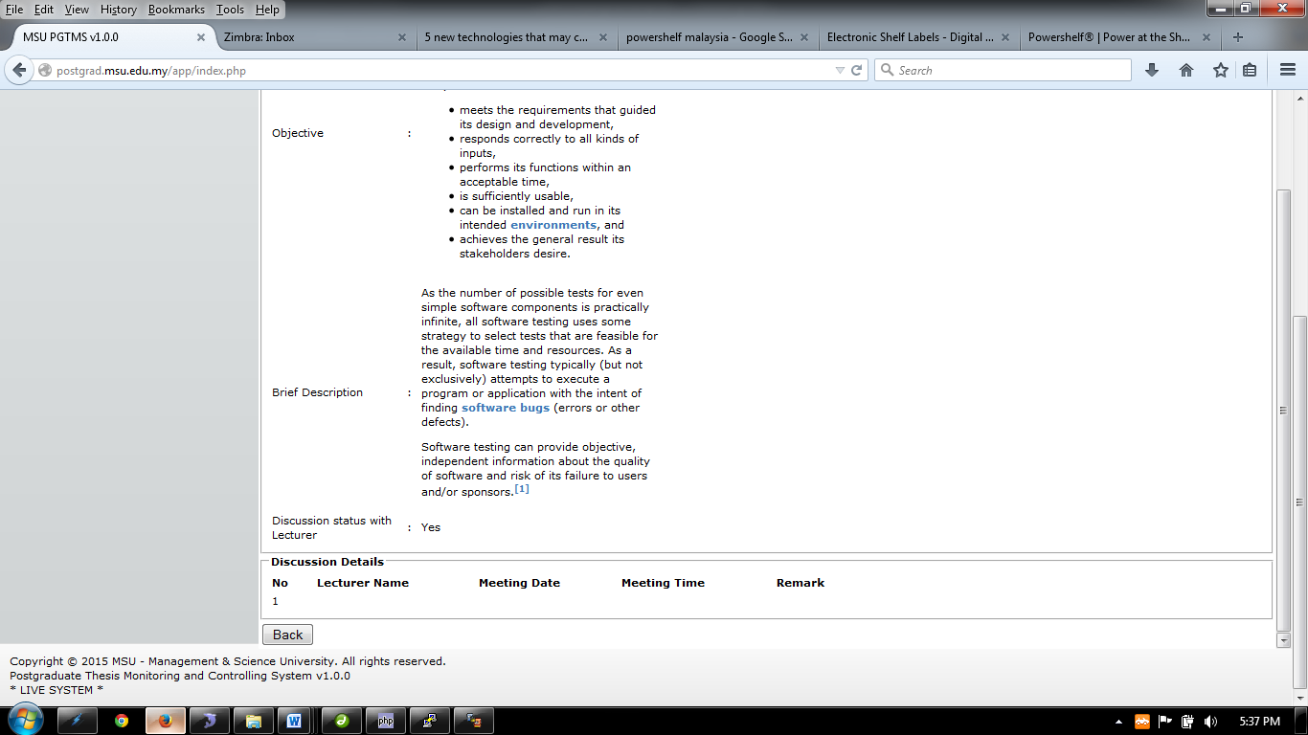

Figure 20: Outline of Resarch/Case Study

**Steps:-**

1. This page only display the thesis detail
2. Click **Back** button to go to previous page.

## Accept/Reject Invitation



Figure 21: Accept/Reject Invitation

**Steps:-**

1. Tick on the checkbox, and click **Accept Invitation** button to accept or click **Not Accept Invitation** to reject invitation.
2. When **Accept Invitation** or **Not Accept Invitation** button is clicked, the email notification will be sent to the faculty by the system (Refer Appendix)

# REVIEWER FEEDBACK

Reviewer Feedback contain list of thesis that been assign by faculty to review.

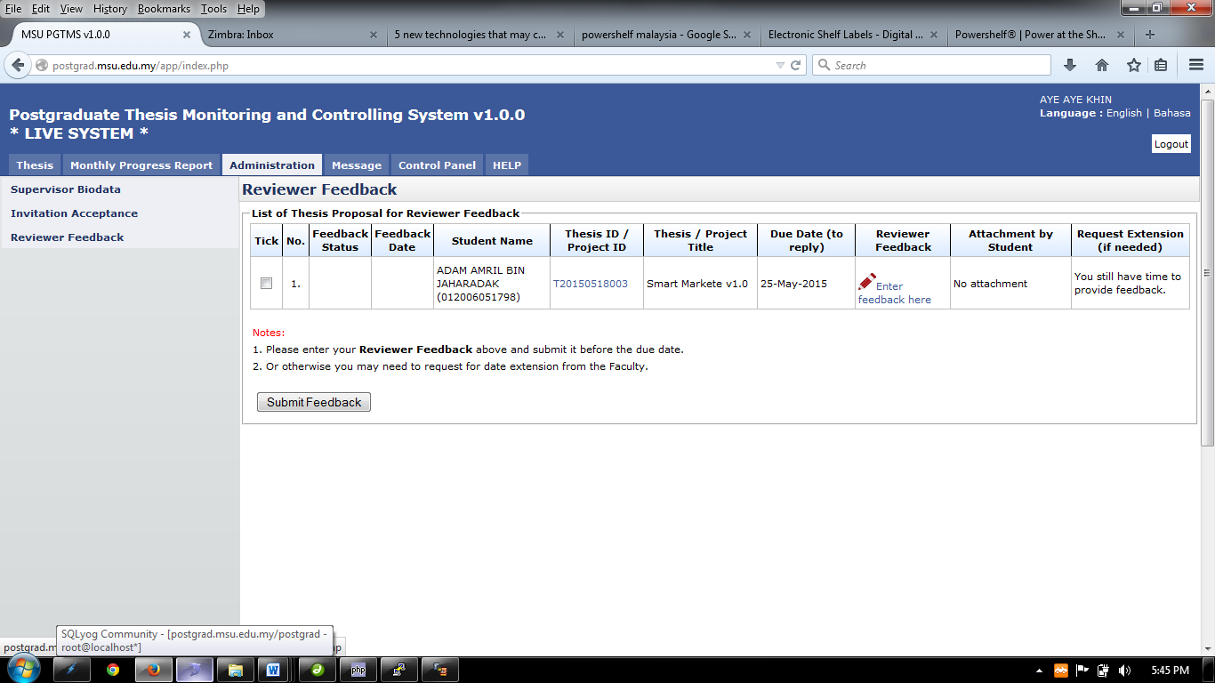

Figure 22: Reviewer Feedback

**Pre-condition**

1. Faculty assign reviewer

**Post-condition**

1. Wait for other thesis proposal for review.

**Steps:-**

1. Click on the **Administration** tab on the system **Top** panel section.
2. The **Administration** menu will be displayed on the system **Left** panel and click on it.
3. 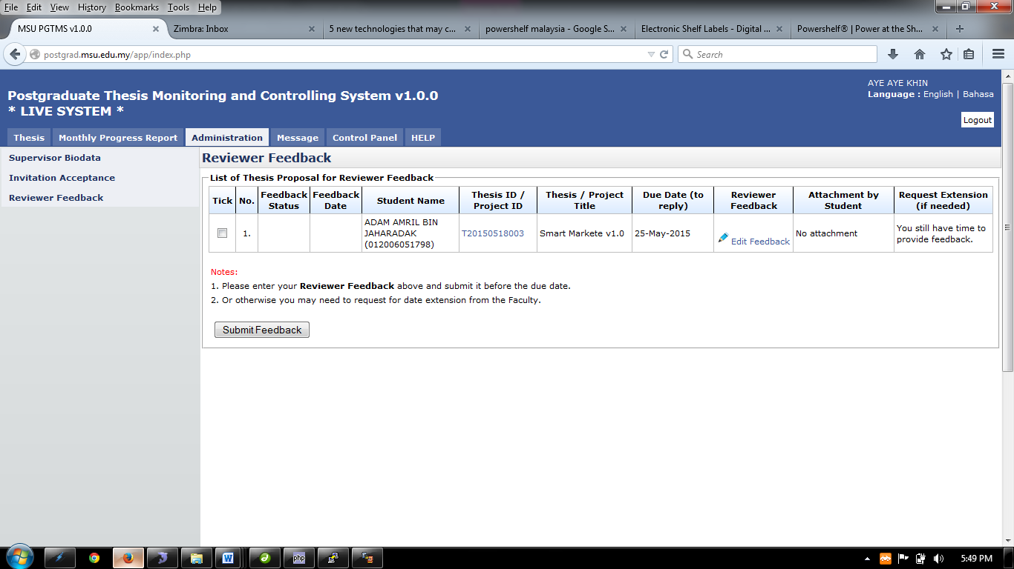Click the **Reviewer Feedback** and the list of thesis proposal for reviewer feedback will be display..
4. To give the feedback or read the feedback or edit feedback, click on the link  (Refer 8.1: Enter Feedback)
5. To View Thesis Detail, Click on Thesis ID. (Refer 8.2: Thesis Detail)

## Enter Feedback

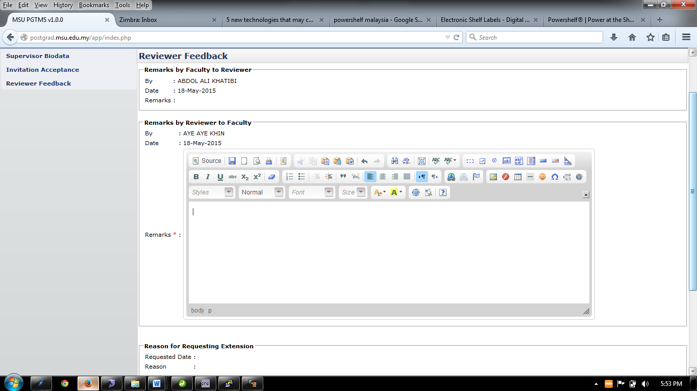

Figure 23: Enter Feedback

**Steps:-**

1. Enter necessary feedback and click **Update** button.
2. To go back to the previous page, click **Back** button

## Thesis Detail

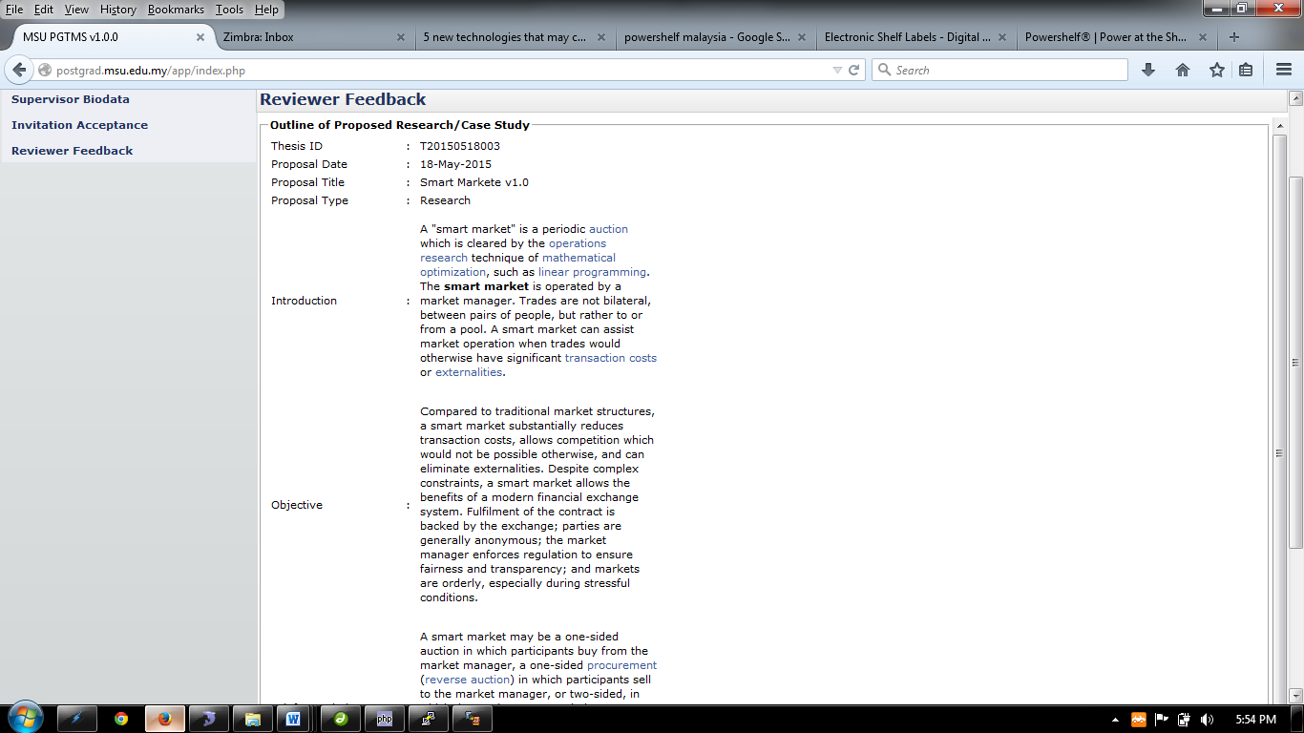

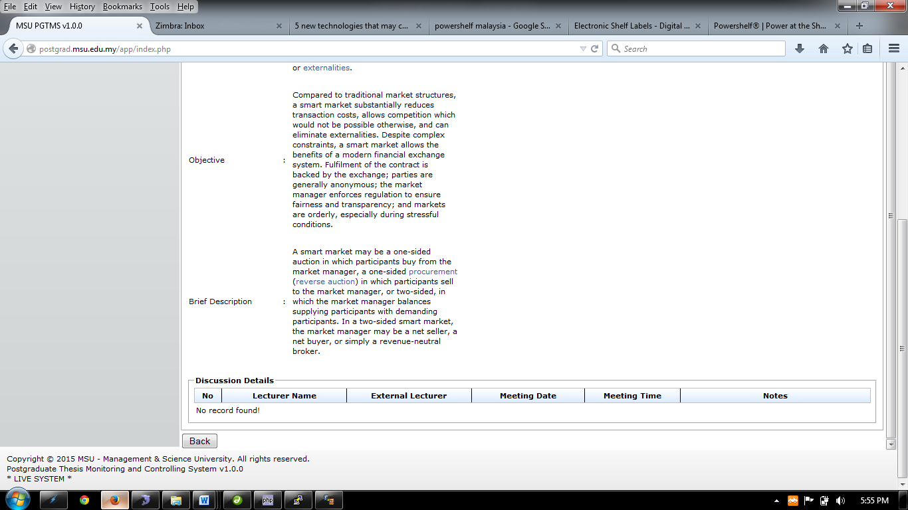

Figure 24: Thesis Detail

**Steps:-**

1. This page only display the thesis detail
2. Click **Back** button to go to previous page.

## Submit Feedback

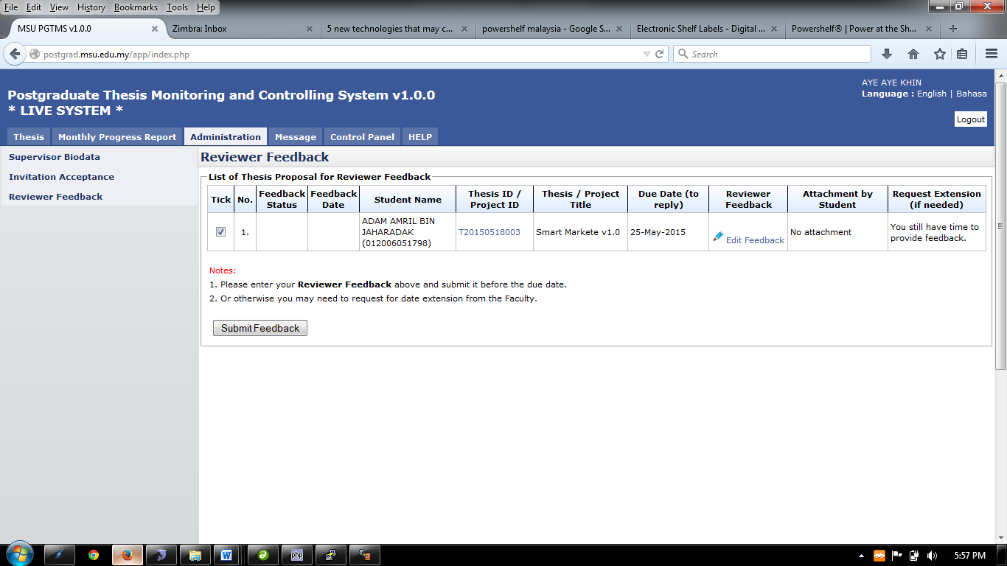

Figure 25: Feedback Submission

**Steps:-**

1. Tick the checkbox and click **Submit Feedback** button to proceed.

# MONTHLY PROGRESS REPORT

## Progress Report History

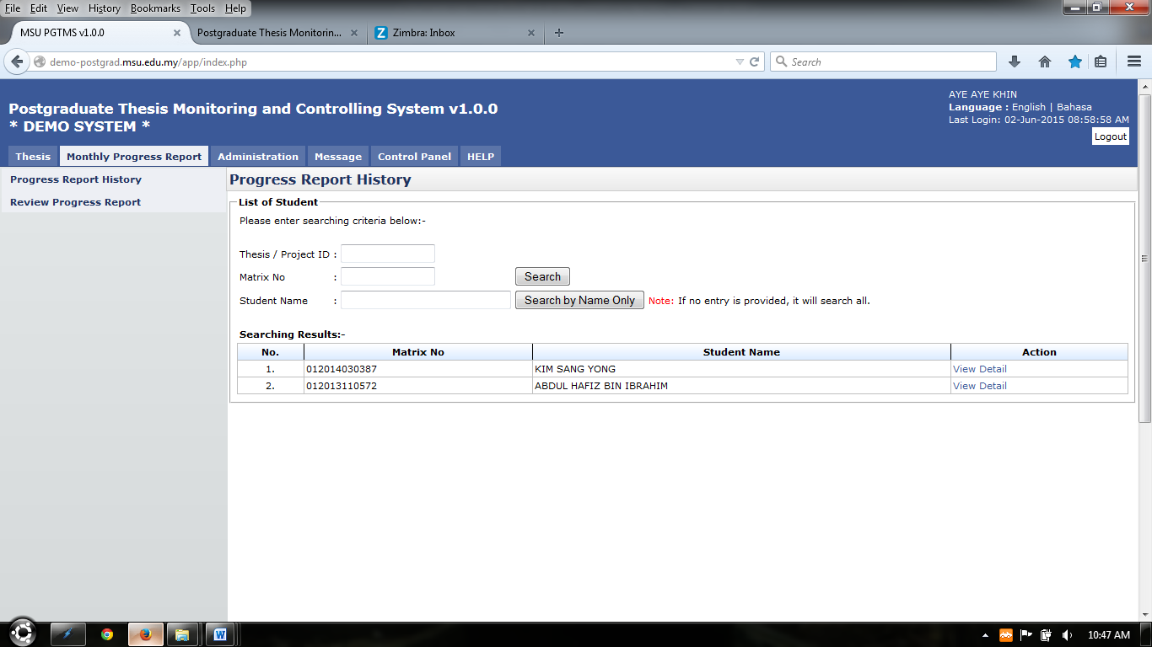Figure 26: Monthly Progress Report

**Pre-condition**

1. Accept senate invitation as Supervisor
2. Supervisee has submitted monthly progress report

**Post-condition**

1. Can view progress report history
2. Can review progress report

**Steps:-**

1. Click on the **Monthly Progress Report** tab on the **Top** panel
2. Click on the **Progress Report History** menu on the **Left** panel
3. System will display list of supervisee assigned
4. To view list of monthly progress report history, click **View Detail** link on the **Action** column(refer figure 26) Refer 10.1.1 View Detail

### View Detail

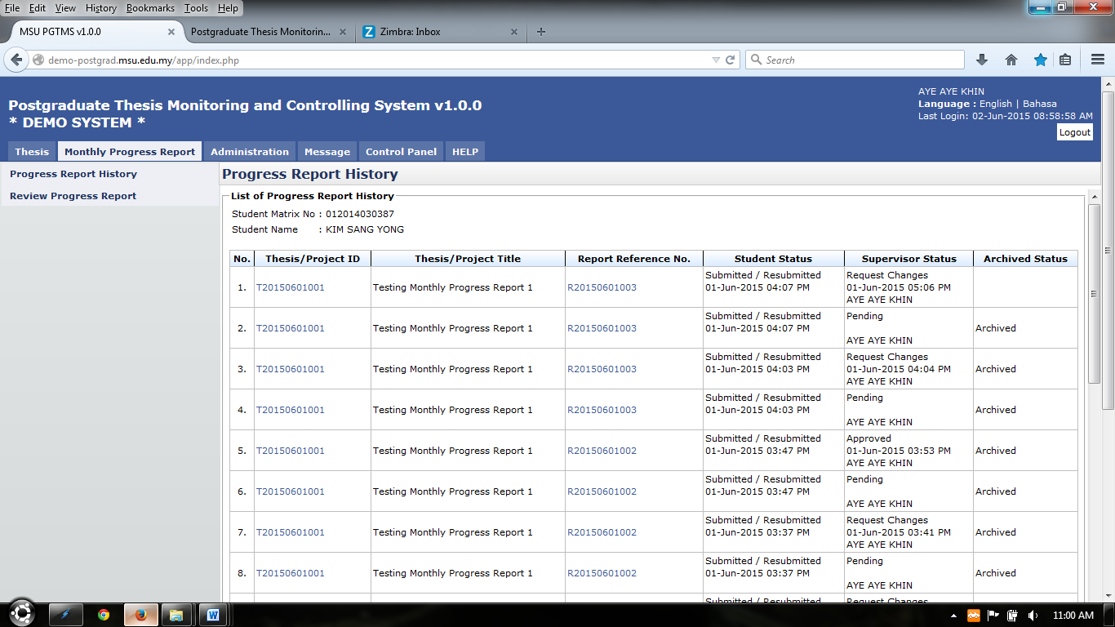

Figure 27: List of Progress Report History

**Steps:-**

1. The list of progress report history will be display
2. To view thesis detail, click on the link at thesis/project id column(refer figure 27)
3. To view progress report detail, click on the link at **Report Reference No.** column (refer figure 27)

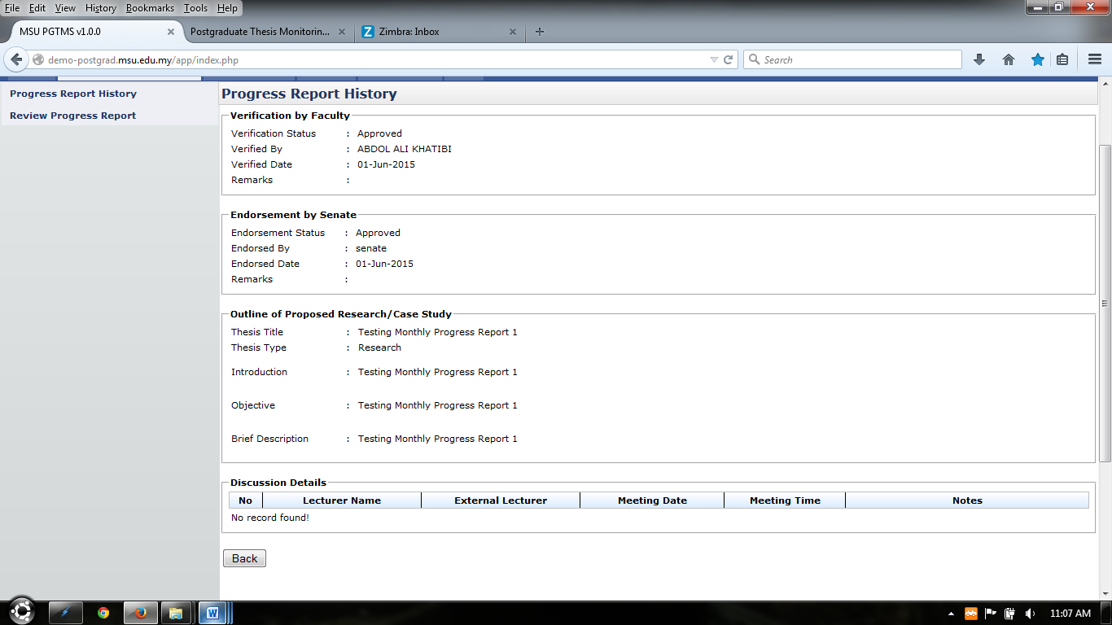

Figure 28: Thesis Detail

**Steps:-**

1. The system will display thesis detail only
2. Click **Back** button to go to previous page.

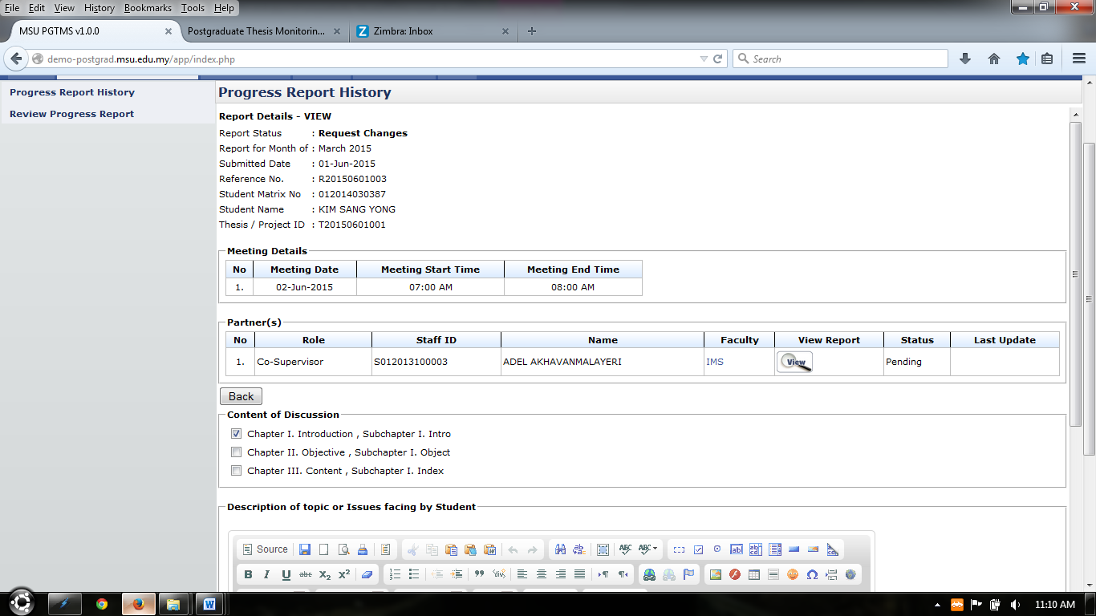

Figure 29: Progress Report History Detail

**Steps:-**

1. The system will display progress report detail only
2. Click **Back** button to go to previous page.

## Review Progress Report

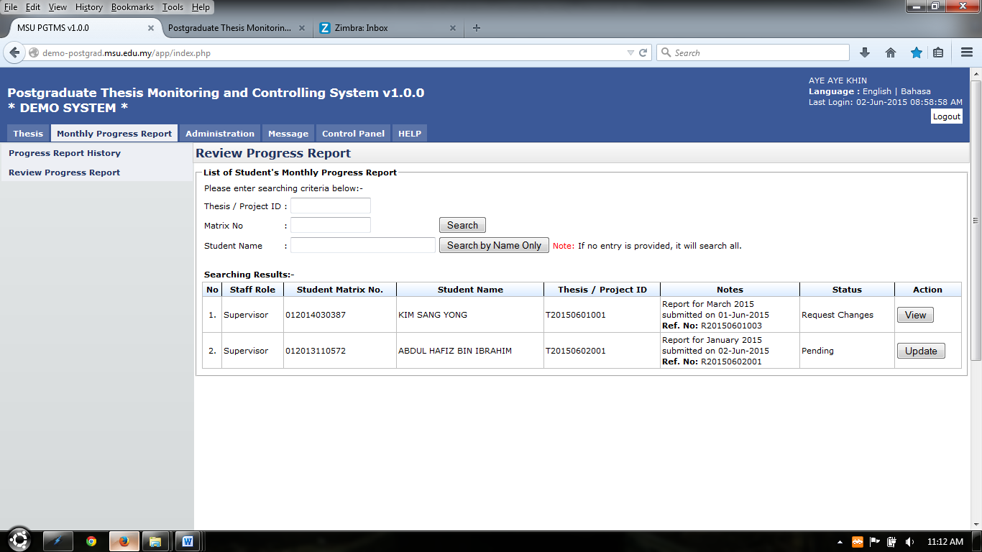Figure 30: Review Progress Report

**Pre-condition**

1. Accept senate invitation as Supervisor
2. Supervisee has submitted monthly progress report

**Post-condition**

1. Can view progress report
2. Wait for supervisee to submit new progress report or changes progress report

**Steps:-**

1. Click on the **Monthly Progress Report** tab on the **Top** panel
2. Click on the **Review Progress Report** menu on the **Left** panel
3. System will display list of supervisee
4. Status of the monthly progress report display on **Status** column
5. To view monthly progress report detail, click **View** button (refer 10.2.1 View Progress Report Detail)
6. To review monthly progress report, click **Update** button (refer 10.2.2 Review Progress Report)

### View Progress Report Detail

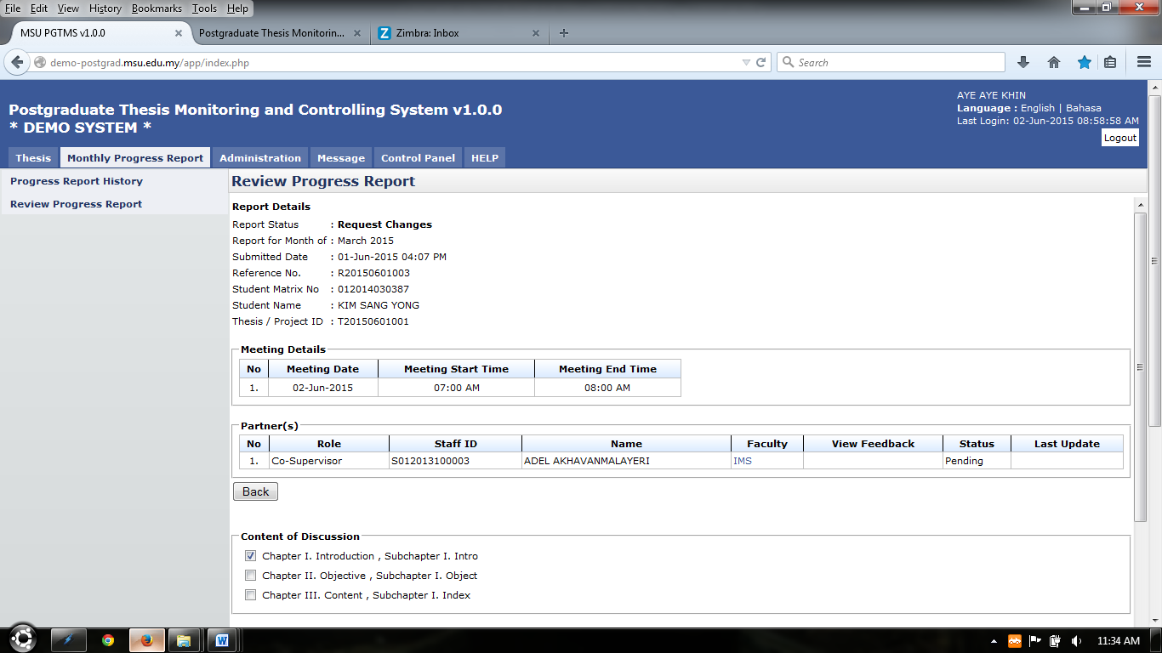

Figure 31: Progress Report Detail

**Steps:-**

1. The progress report detail will be display
2. To download attachment attach on the progress detail click 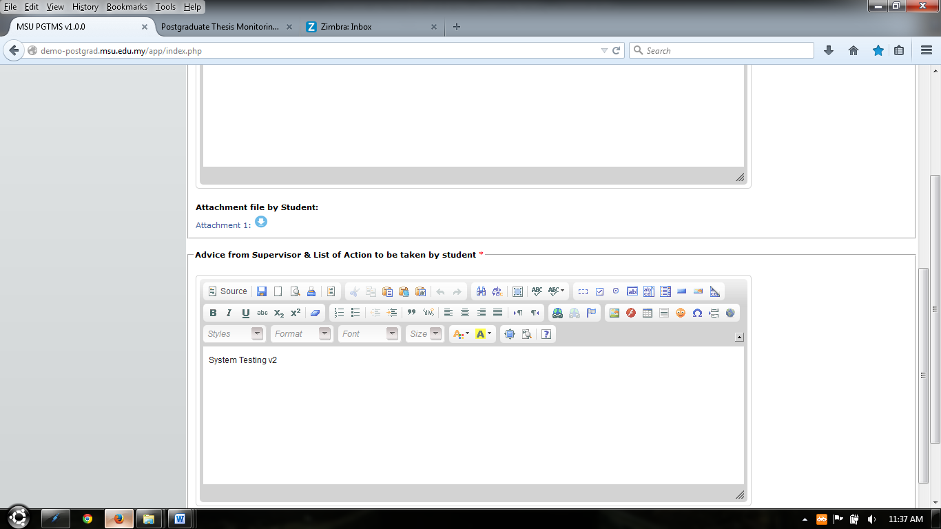
3. Click **Back** button to go back to previous page.



Figure 32: Progress Report Detail

### Review Progress Report

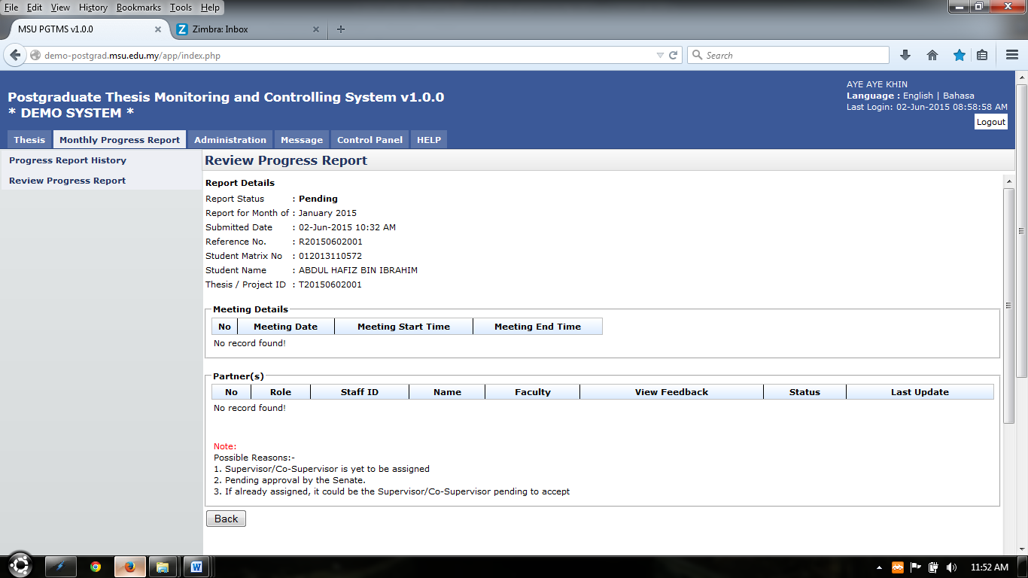

Figure 33: Review Progress Detail

**Steps:-**

1. The progress report detail will be display, it can be update necessarily up to supervisor
2. To download attachment uploaded by student, click 
3. Click **Back** button to go back to previous page.
4. To upload attachment click **Attachment** button (refer 10.2.2.1 Upload Attachment)
5. To request changes of the progress report, click **Request Changes** button
6. To approve progress report, click **Approved** button.
7. To save first before submitting, click **Save** button.
8. To go back to previous page, click **Back** button.
9. **Approved** and **Request Changes** button will trigger notification email to student (Template refer Appendix)



Figure 34: Progress Report Detail

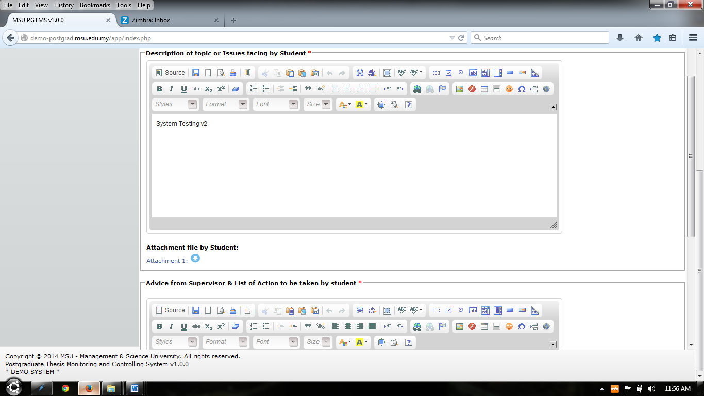

Figure 35: Issue facing by Student

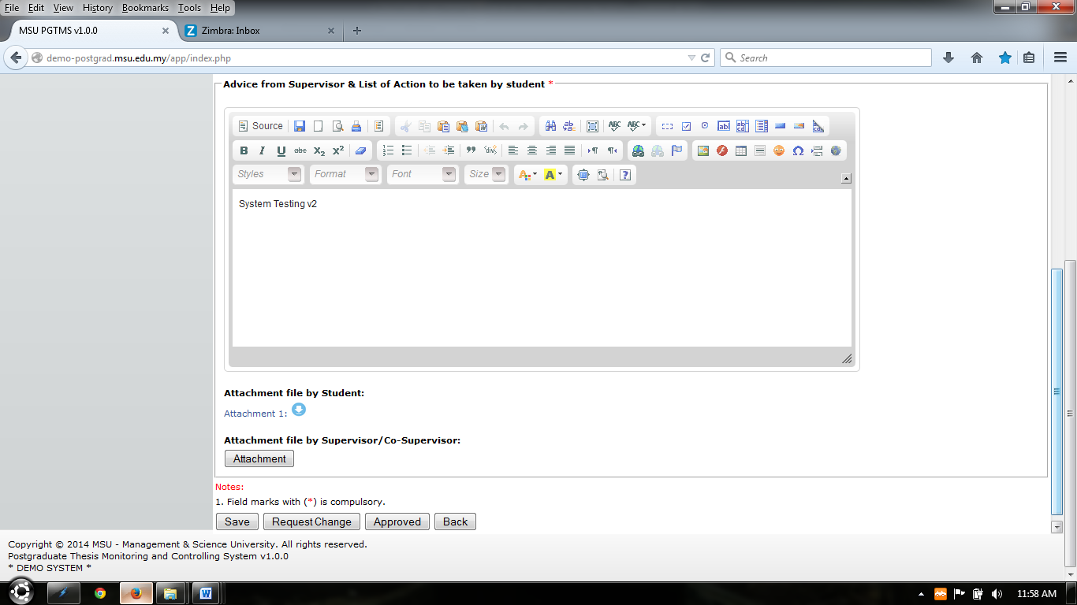

Figure 36: Advice from Supervisor

#### Upload Attachment

#### 

Figure 37: Upload Attachment

**Steps:-**

1. Click **Add Attachment** button (refer figure 37)
2. Popup display shown on figure 38 will be shown.
3. Click **Browse** button and popup show on figure 38 will be shown and choose necessary attachment to upload. Then click **Open** button to confirm attachment chosen. (refer figure 38)
4. Enter file description on the field provided (refer figure 38)
5. Click **Insert Attachment** to proceed
6. Popup show on figure 40 will be shown, click **Done** button to proceed

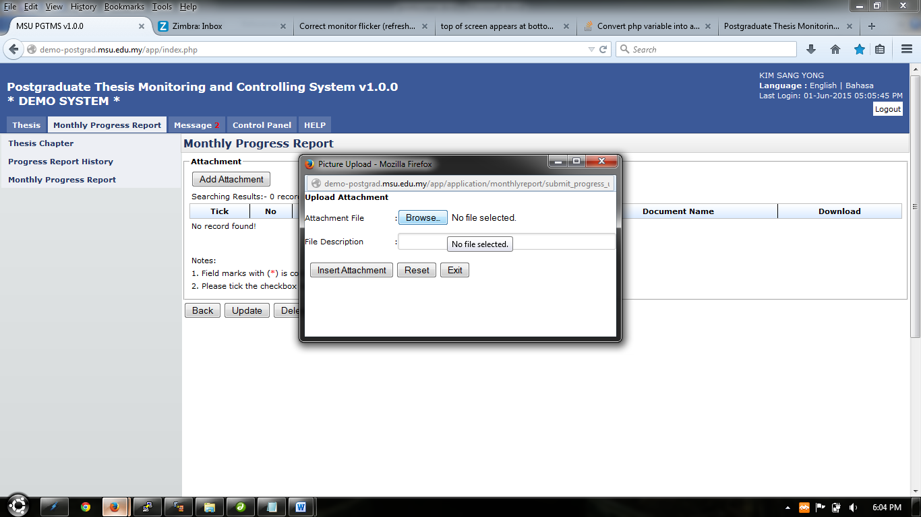

Figure 38: Browse

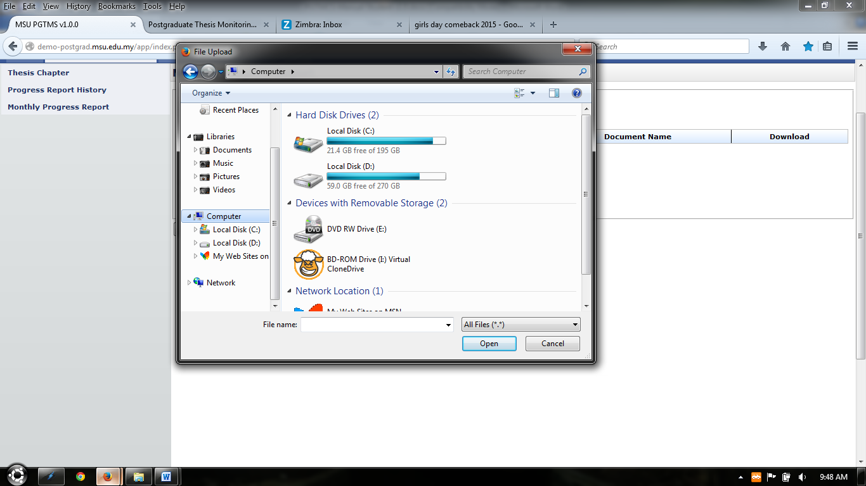

Figure 39: Choose Attachment

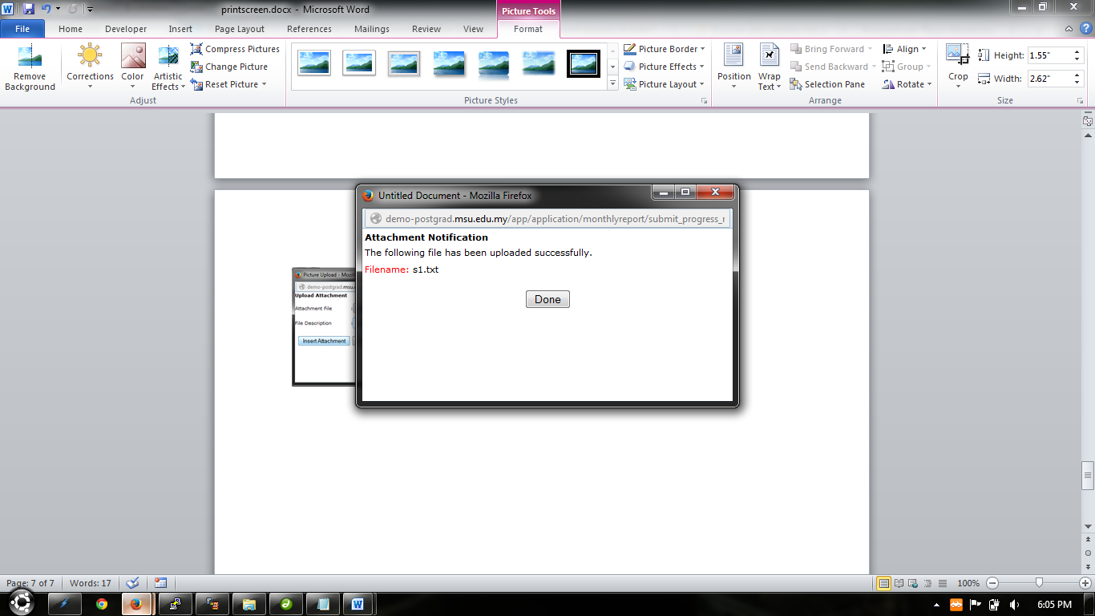

Figure 40: Finish Upload

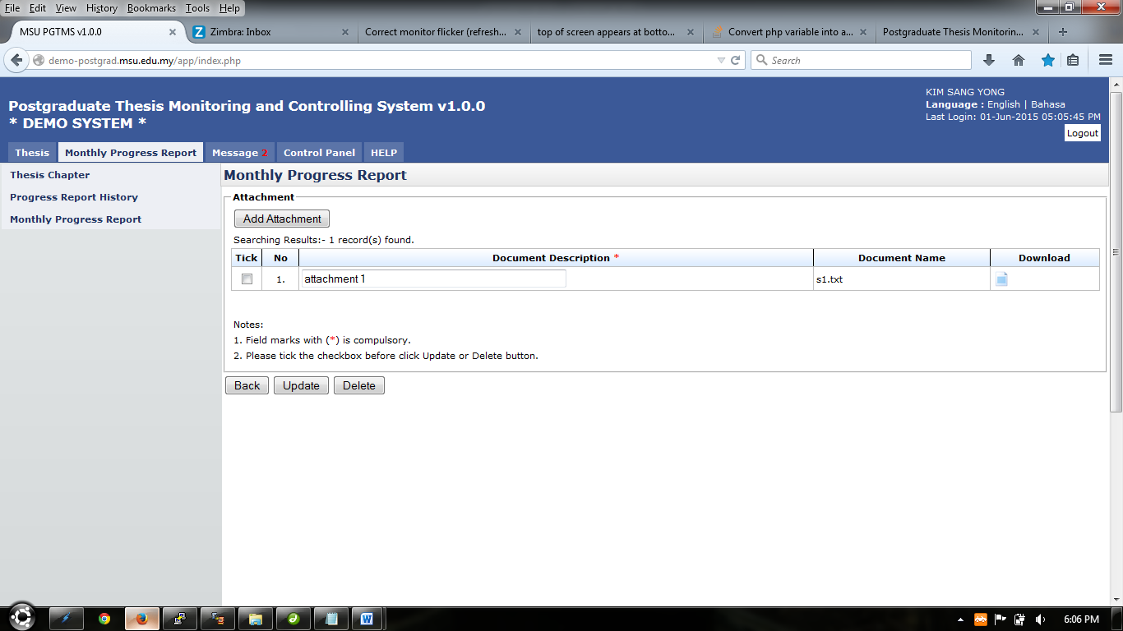

Figure 41: List of attachment

1. To update attachment description, change necessary description on the field, tick on the checkbox on the far left side. Then click **Update** button to proceed.
2. To delete attachment, tick on the checkbox on the far left side and click **Delete** button to delete.
3. To download or open attachment uploaded, click to download or open attachment.
4. To go back to previous page, click **Back** button.
5. The previous page will show how many attachment that has been uploaded at the **Attachment** button. (refer figure 42)

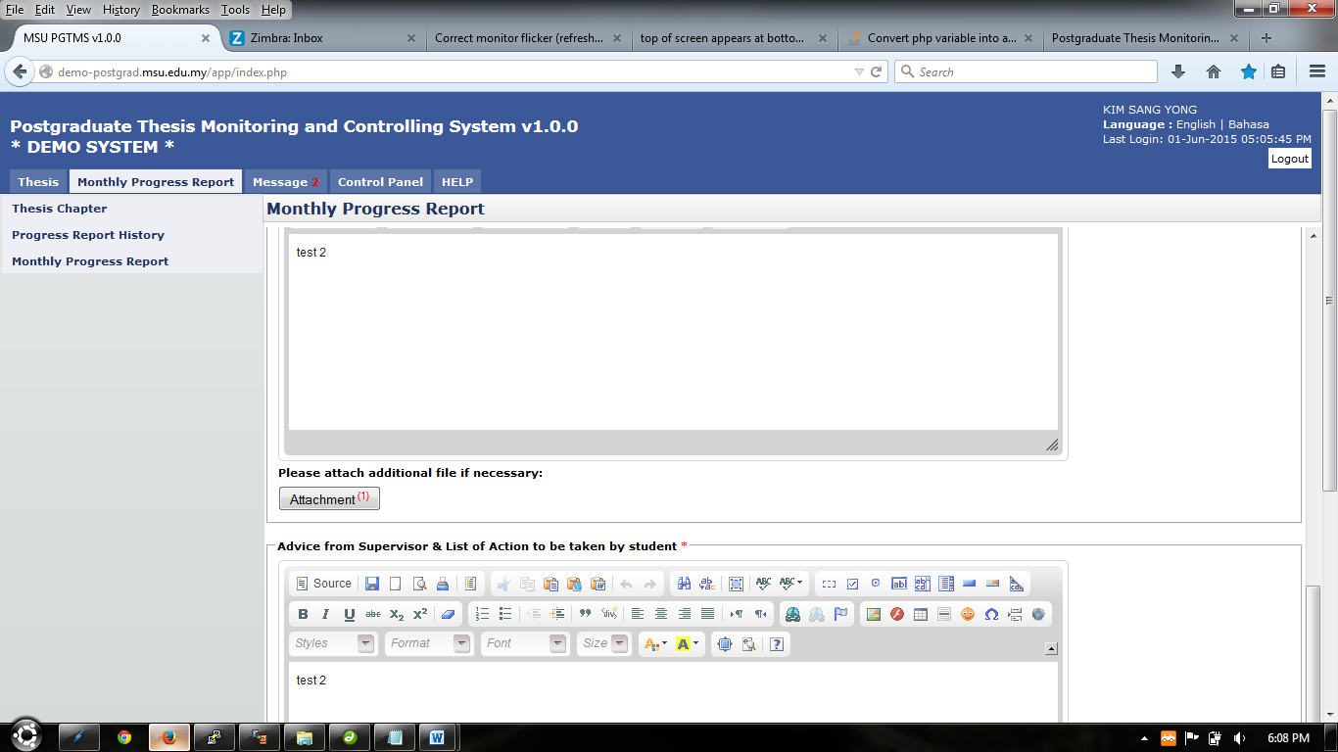

Figure 42: Finish uploading

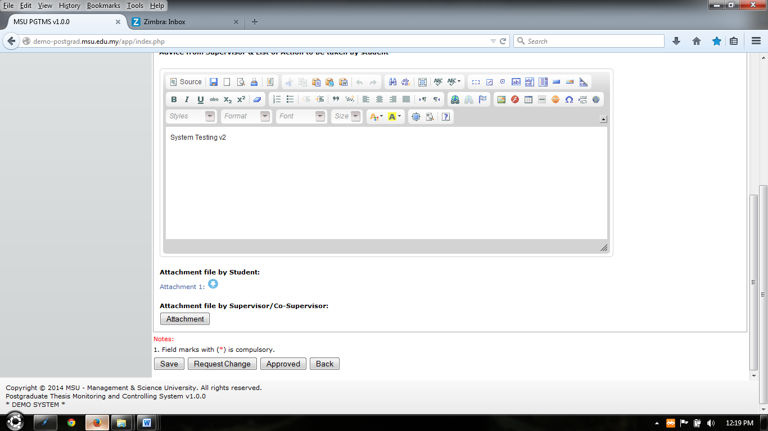

Figure 43: Supervisor Decision

# Message

## Inbox

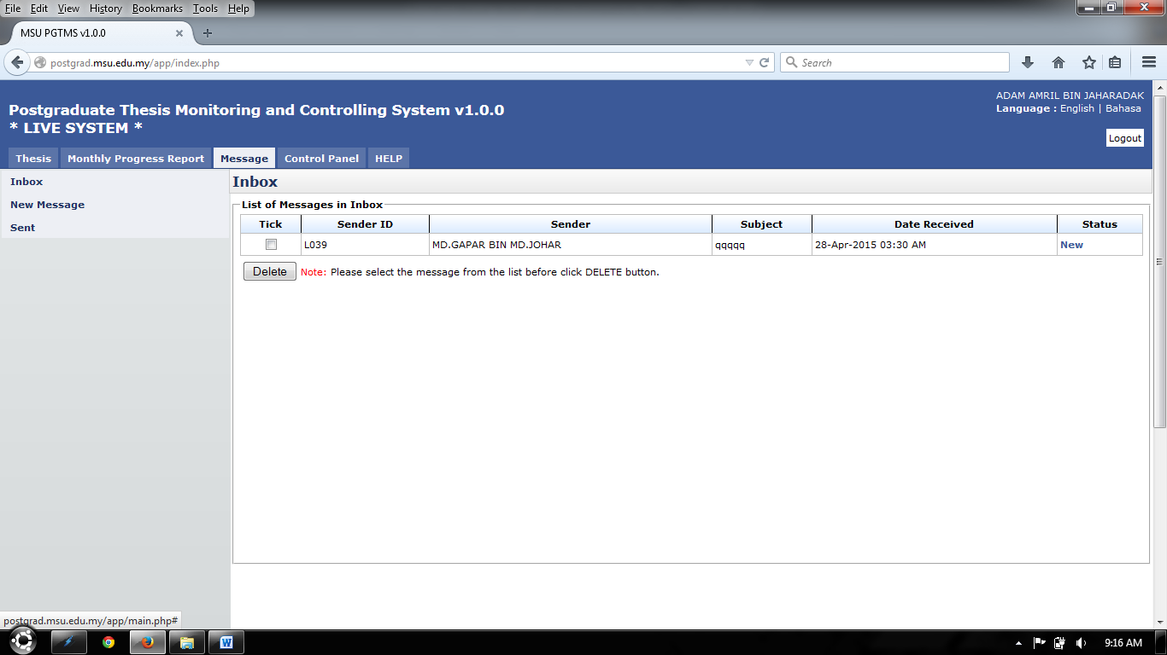

Inbox Menu

Figure 44: Message

**Steps:-**

1. Click on the **Message** tab on the **Top** panel
2. Click on the **Inbox** menu on the **Left** panel
3. System will display the list of message that been receive by user.
4. On the far right side, it will display the status of the message whether is **New** or **Read**
5. To read the message, click on the link on the right side which is in **Status** column. (Refer View Message)
6. To delete message, tick on the checkbox in **Tick** column, and click **Delete** button

### View Message

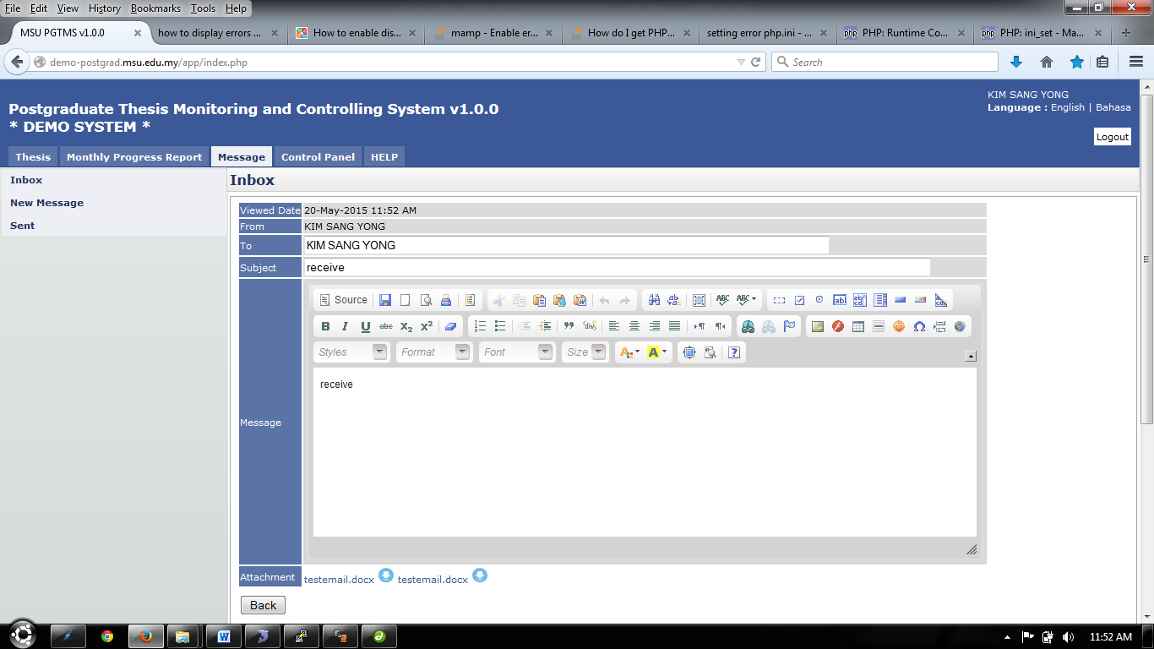

Figure 45: Read Message

**Steps:-**

1. This page only displays the message that has been open by the user.
2. To view or download the attachment that been sent, click  or link shown on figure 45
3. To go back to the previous page, click **Back** button.

## New Message

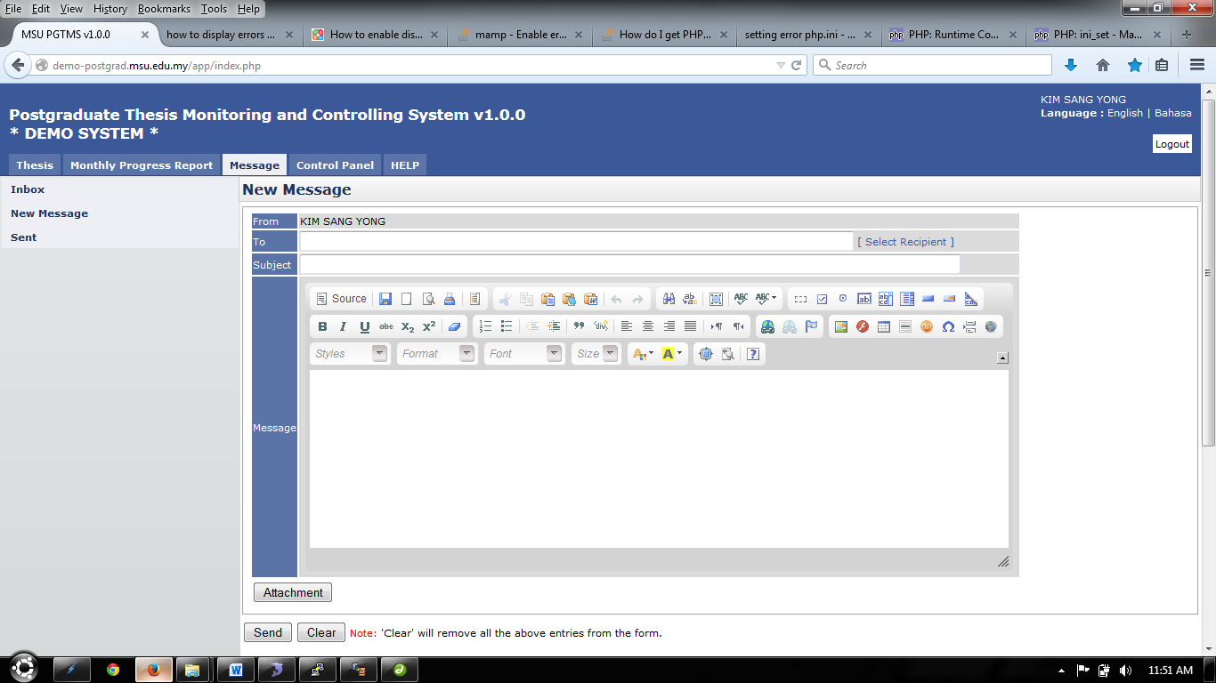

Figure 46: New Message

**Steps:-**

1. Click on the **Message** tab on the **Top** panel
2. Click on the **New Message** menu on the **Left** panel
3. To select recipient, click. Next step refer Select Recipient
4. Insert or enter necessary detail in **Subject** and **Message**.
5. To upload or include attachment for message, click **Attachment** button. Next step refer Upload Attachment.
6. To erase or clear the entire entries, click **Clear** button.
7. To send the message, click **Send** button.

### Select Recipient

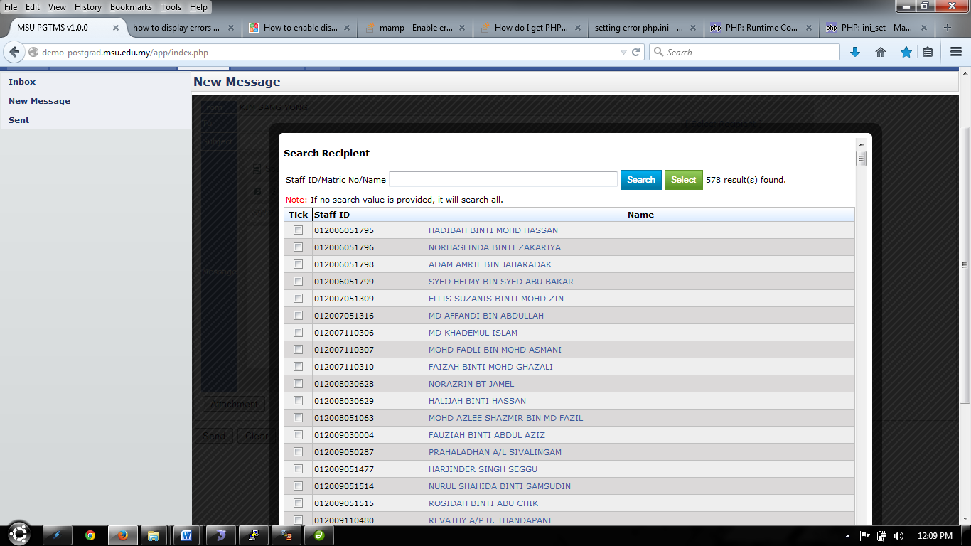

Single recipient can be select by click on the name displayed.

Figure 47: Select Recipient

**Steps:-**

1. Enter or insert **Name** or **Staff ID** or **Matric No** and click **Search** button.
2. The system will display the result based on searching criteria.
3. To select one recipient only, click on the **Name** displayed.
4. To select multiple or single recipient, tick on the checkbox on the left.
5. Then click **Select** button to proceed.
6. To go back to the previous page, click on the **Black** field surrounding the page. Refer Figure 48



Click the **Black** field, to go back to previous page

Figure 48: Select Recipient- Next Section

### Upload Attachment

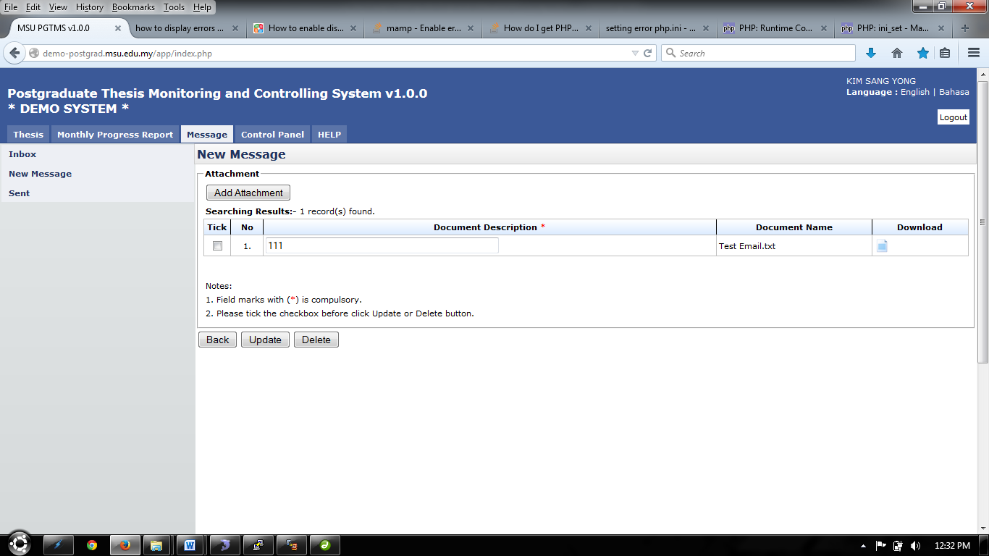

Figure 49: Upload Attachment

**Steps:-**

1. To add attachment, click **Add Attachment** button. (Refer Figure 49)

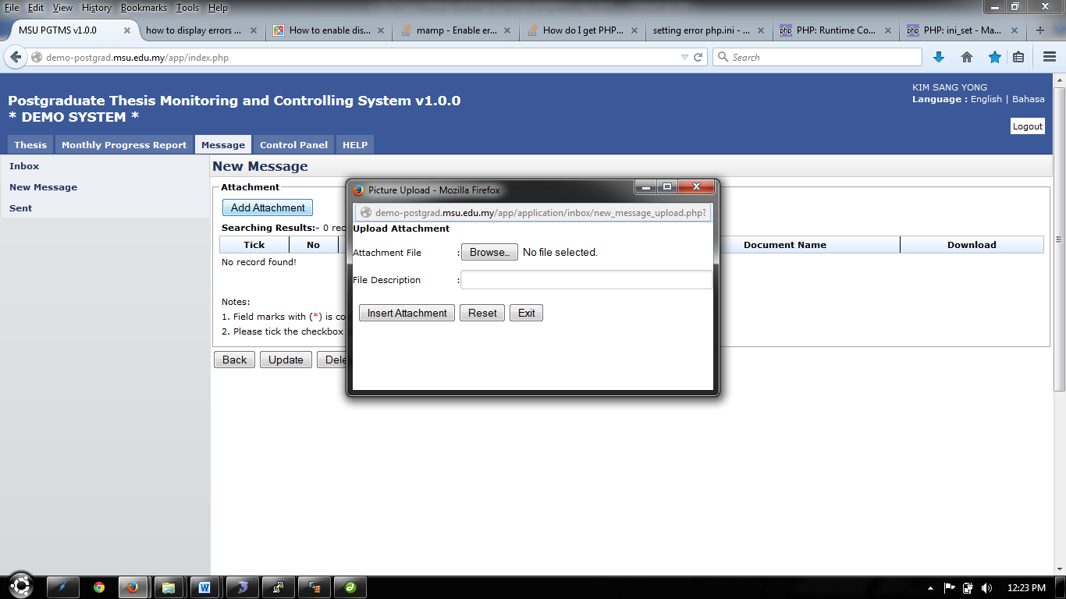

Figure 50: Upload Attachment- Next Section

1. To choose attachment, click Browse.. button and choose the file to upload.
2. To file description can be insert in the field provided.
3. Click Insert Attachment button to proceed.
4. To clear all the entries, click Reset button.
5. To exit or close the popup, click Exit button.
6. To upload more file, repeat step 1 until step 4.
7. To edit file description, change necessary detail, then tick the checkbox and click Update button to proceed.
8. To delete file, tick the checkbox and click Delete button.
9. To download or open the file that has been uploaded, click 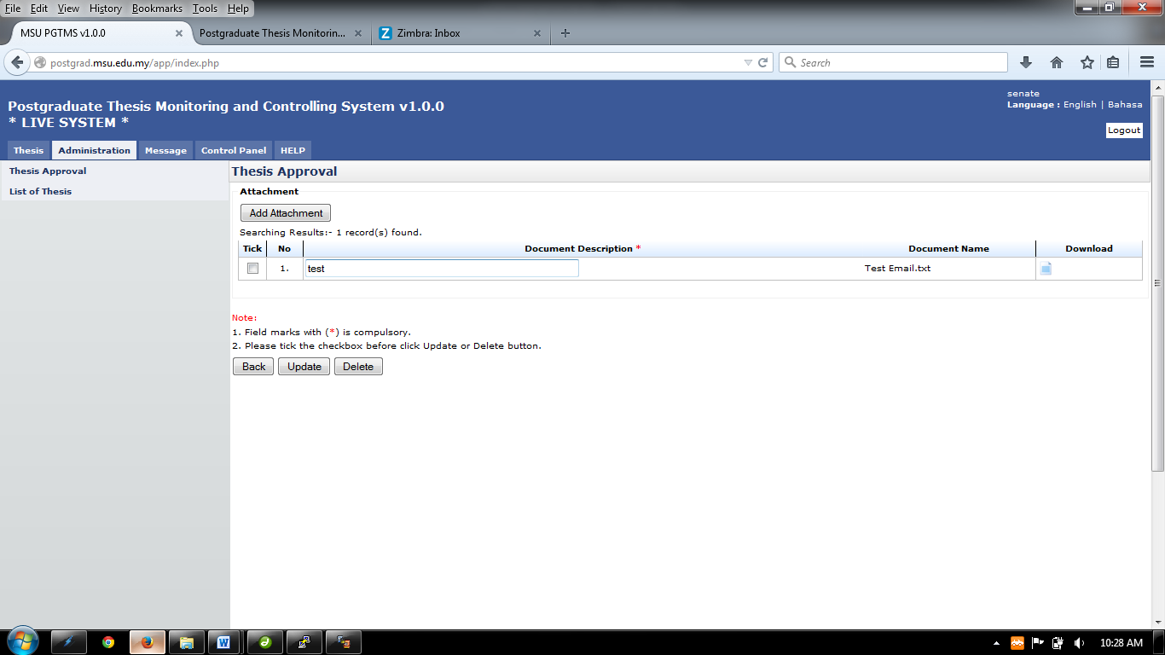on the Download column.
10. To go back to previous page, click Back button

## Sent

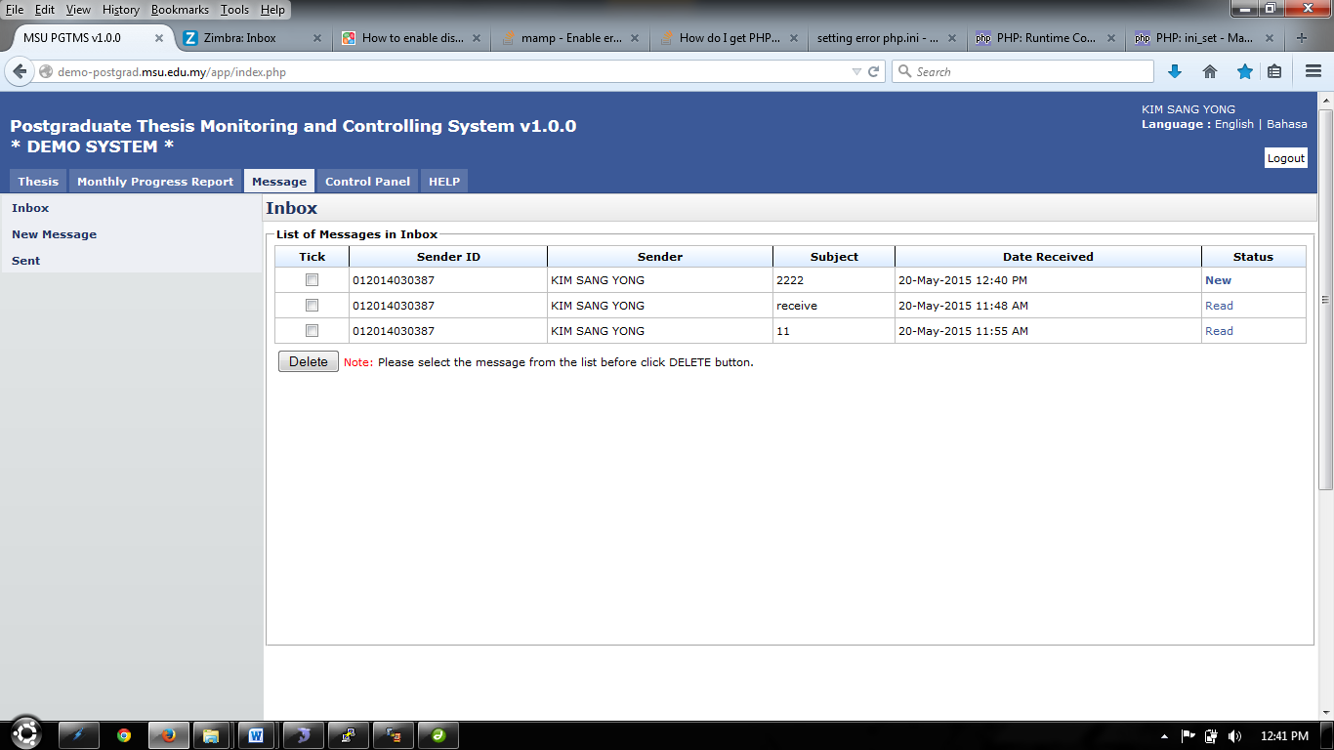

Figure 51: Sent

**Steps:-**

1. After message has been sent, it will be display in **Sent** Left panel
2. Click **Message** tab on **Top** panel
3. Click on the **Sent** on the **Left** panel
4. The system will show the list of message that has been sent by user.
5. The status of the message also had been show on the far right side which is in **Status** column. If the message has been read by recipient, it will display **Read.** If not, it will display **New.**
6. Click the link on the **Status** column to read the message. (Refer Read Message)
7. To delete message, tick the checkbox and click **Delete** button.

### Read Message



Figure 52: Read Message

**Steps:-**

1. This page only displays the message that has been open by the user.
2. To view or download the attachment that been sent, click  or link shown on figure 52.
3. To go back to the previous page, click **Back** button.

APPENDIX

# Email Template - Faculty to Student

## Thesis Proposal - Request Change

To: [kimsangyong@msu.edu.my](mailto:kimsangyong@msu.edu.my) <[kimsangyong@msu.edu.my](mailto:kimsangyong@msu.edu.my)>

From: [mdgapar@msu.edu.my](mailto:mdgapar@msu.edu.my) <[mdgapar@msu.edu.my](mailto:mdgapar@msu.edu.my)>

Cc: [gsm@msu.edu.my](mailto:gsm@msu.edu.my) <[gsm@msu.edu.my](mailto:gsm@msu.edu.my)>

Subject: Thesis Proposal by KIM SANG YONG



|  |  |
| --- | --- |
| Dear KIM SANG YONG, |  |
| Please be informed, your thesis proposal status has been responded by the Faculty with the following status. |  |
|  |  |

|  |  |
| --- | --- |
| **Student Name** | KIM SANG YONG |
| **Matric No** | 012014030387 |
| **Thesis ID** | T20150513001 |
| **Submit Date** | 13-May-2015 |
| **Thesis/Project Title** | 33333333- edit_proposal.php |
| **Proposal Type** | Research |
| **Faculty Proposal Status** | Request Changes |

Thank you,

Best Regards,

Management & Science University

Please do not reply directly to this email. © MSU 2015All rights reserved.  
  
Management & Science University.  
University Drive, Off Persiaran Olahraga,  
Section 14, 40100 Shah Alam,  
Selangor Darul Ehsan.

## Thesis Proposal - Disapproved

To: [kimsangyong@msu.edu.my](mailto:kimsangyong@msu.edu.my) <[kimsangyong@msu.edu.my](mailto:kimsangyong@msu.edu.my)>

From: [mdgapar@msu.edu.my](mailto:mdgapar@msu.edu.my) <[mdgapar@msu.edu.my](mailto:mdgapar@msu.edu.my)>

Cc: [gsm@msu.edu.my](mailto:gsm@msu.edu.my) <[gsm@msu.edu.my](mailto:gsm@msu.edu.my)>

Subject: Thesis Proposal by KIM SANG YONG



|  |  |
| --- | --- |
| Dear KIM SANG YONG, |  |
| Please be informed, your thesis proposal status has been responded by the Faculty with the following status. |  |
|  |  |

|  |  |
| --- | --- |
| **Student Name** | KIM SANG YONG |
| **Matric No** | 012014030387 |
| **Thesis ID** | T20150513001 |
| **Submit Date** | 13-May-2015 |
| **Thesis/Project Title** | 33333333- edit_proposal.php |
| **Proposal Type** | Research |
| **Faculty Proposal Status** | Disapproved |

Thank you,

Best Regards,

Management & Science University

Please do not reply directly to this email. © MSU 2015All rights reserved.  
  
Management & Science University.  
University Drive, Off Persiaran Olahraga,  
Section 14, 40100 Shah Alam,  
Selangor Darul Ehsan.

# Email Template - Supervisor to Student

## Monthly Progress Report - Request Change

To: [kimsangyong@msu.edu.my](mailto:kimsangyong@msu.edu.my) <[kimsangyong@msu.edu.my](mailto:kimsangyong@msu.edu.my)>

From: [mdgapar@msu.edu.my](mailto:mdgapar@msu.edu.my) <[mdgapar@msu.edu.my](mailto:mdgapar@msu.edu.my)>

Subject: Monthly Progress Report Submitted by KIM SANG YONG



|  |  |
| --- | --- |
| Dear Sir, |  |
|  |  |
| I am pleased to submit the review of monthly progress report as follows :-. |  |
|  |  |

|  |  |
| --- | --- |
| **Student Name** | ABDUL HAFIZ BIN IBRAHIM |
| **Matric No** | 012013110572 |
| **Thesis ID** | T20150602001 |
| **Thesis Title** | System testing v2 |
| **Month** | January 2015 |
| **Reference No** | R20150602001 |
| **Submission Date** | 02-Jun-2015 12:24 PM |
| **Respond Date** | 02-Jun-2015 10:32 AM |
| **Status** | Request Changes |

Thank you,

Best Regards,

AYE AYE KHIN

Please do not reply directly to this email. © MSU 2015All rights reserved.  
  
Management & Science University.  
University Drive, Off Persiaran Olahraga,  
Section 14, 40100 Shah Alam,  
Selangor Darul Ehsan.

## Monthly Progress Report - Approved

To: [kimsangyong@msu.edu.my](mailto:kimsangyong@msu.edu.my) <[kimsangyong@msu.edu.my](mailto:kimsangyong@msu.edu.my)>

From: [mdgapar@msu.edu.my](mailto:mdgapar@msu.edu.my) <[mdgapar@msu.edu.my](mailto:mdgapar@msu.edu.my)>

Subject: Monthly Progress Report Submitted by KIM SANG YONG



|  |  |
| --- | --- |
| Dear Sir, |  |
|  |  |
| I am pleased to submit the review of monthly progress report as follows :-. |  |
|  |  |

|  |  |
| --- | --- |
| **Student Name** | ABDUL HAFIZ BIN IBRAHIM |
| **Matric No** | 012013110572 |
| **Thesis ID** | T20150602001 |
| **Thesis Title** | System testing v2 |
| **Month** | January 2015 |
| **Reference No** | R20150602001 |
| **Submission Date** | 02-Jun-2015 12:24 PM |
| **Respond Date** | 02-Jun-2015 10:32 AM |
| **Status** | Approved |

Thank you,

Best Regards,

AYE AYE KHIN

Please do not reply directly to this email. © MSU 2015All rights reserved.  
  
Management & Science University.  
University Drive, Off Persiaran Olahraga,  
Section 14, 40100 Shah Alam,  
Selangor Darul Ehsan.

This page is intentionally left blank.